Table of Contents

1. Abbreviations and terms used 2
2. Annotation 3
3. Assumptions and limitations 6
4. Methodology for forecasting changes in construction costs 7
4.1. Obtaining data characterizing changes in construction costs 7
4.2. Statistical data 8
4.3. Expert evaluations 10
4.4. Data analysis 13
5. Analysis of the results of the general and sub-sectoral expert survey 19
5.1. Structure and course of the general and sub-sectoral expert survey 19
5.2. Factors influencing changes in labor and construction material costs 20
5.3. Impact of measures to combat the shadow economy 30
5.4. Impact of COVID-19 on the construction industry 34
5.5. Forecast of changes in the volume and cost of construction output 35
5.6. Impact of construction output on costs and industry average profit margin 45
Conclusions 56
Appendixes 61

Abbreviations and terms used
Abbreviation | Explanation
CFLA | Central Finance and Contracts Agency
CSP | Central Statistical Bureau
EM | Ministry of Economics of the Republic of Latvia
EU | The European Union
Eurostat | Statistical Office of the European Commission
CAGR | Compound growth over several years
GDP | Gross domestic product
Customer | Ministry of Economics of the Republic of Latvia
Performer | „InnoMatrix“ LLC
Research | Final handover, report “Research on projected changes in labor and construction material costs in the construction sector in Latvia”

Annotation

The “Study on Forecasted Changes in Labor and Building Materials Costs in the Construction Sector in Latvia” has been prepared in accordance with the agreement signed on July 22, 2020 between the Ministry of Economics of the Republic of Latvia and the research company SIA InnoMatrix.
The aim of the study is to forecast changes in labor and construction material costs in the construction sector in Latvia in the period from 2020 to 2024 using a reusable research methodology.
The study includes a detailed assessment and forecasts for the period from 2020 to 2024 both on the total construction volume and costs, and on the following sub-sectors of the construction industry - residential buildings, non-residential buildings, engineering structures, transport facilities, underground main pipelines, industrial production of complex buildings. companies in construction and construction of other civil engineering works.
In the course of the research, the factors influencing the costs of labor and construction materials were assessed and analyzed, including the proportions of both directly and indirectly influencing indicators, such as measures to combat the shadow economy, lending, availability of financing and labor. The study also assessed the impact of external factors such as the EU common market and EU decisions.
The methodology developed and used in the study included the use of both statistical and expert methods and a combination of methods. The data used in the study were data available from the CSB and expert interviews with representatives of the construction industry and experts from the construction industry sub-sectors. To assess the impact of general factors, the study also included forecasts from macroeconomic experts. At least four experts were involved in each expert group. The staffing and selection of the expert group took place in stages by identifying the companies according to the ranking of turnover, the main region of operation, the level of competence, which is based on diversification according to the criteria of the 2nd level.
The research data set consists of statistical data. Within the framework of expert interviews, the factors influencing the changes in construction costs, the level of their impact, and expert assessments of price change trends were identified. For the identified factors, the series of dynamics with their previous development were retrieved.
Various analysis methods were used for the analysis of statistical data and expert evaluations obtained in the evaluation, according to the research task, data development trends and the scale of expert evaluations. To determine the further development of cost changes, various types of models were used, which characterize the further development of the main trends of the dynamics series over time, based on the extrapolation of previous trends. The obtained models were evaluated for quality with variance indicators.
Depending on the form and scale of the questions used, calculations of aggregate means, structure means, scatter and variation indicators were used in the processing of expert assessments. In addition to a separate analysis of statistical information and expert judgment, combined forecasts were used as the final forecasting tool, combining the various sources of information used in the study. This was done with the aim of compensating for errors and improving the reliability of the final forecast.

The main conclusions of the research are:

- Experts predict a very small increase in construction output in 2020, but from next year the industry could gradually recover by growing by a few percentage points each year, reaching 4.26% growth in 2022 and 6.05% growth in 2024. . The volume of construction output could recover faster in the railway, bridge and tunnel construction sub-sectors. By contrast, the residential and non-residential building and other civil engineering sub-sectors could continue to decline in 2020 and 2021, by a few per cent per year in building construction and by 11.10% in 2020 in the other civil engineering sub-sector.
- Throughout the period from 2020 to 2024, both expert and combined forecasts together project a further increase in construction costs. In the period from 2020 to 2022, this increase would be measurable at 1-5% per year, but in 2024 it could reach the level of 6%.
The most significant increase in costs is forecast for workers' wages, where the combined forecast from 2020 to 2024 will increase from 8% to 10% per year in general.
In terms of sub-sectors, a decrease in construction costs in 2020 is forecasted in the construction of residential and non-residential buildings, as well as in the construction of roads and highways. In turn, the fastest growth is forecasted in the construction of bridges and tunnels. Already from 2022, an increase in costs is forecast in all sub-sectors, leading the way in the construction of railways, bridges and tunnels with an increase in costs in the range of 5-7% per year
- According to experts, the greatest impact on labor costs in construction will be left by labor tax rates and the volume of construction in Latvia. The level of wages in the EU is also given high priority. The volume of construction materials in Latvia, the total EU construction demand and the price of fuel in Latvia could have the greatest impact on the costs of construction materials.
- In general, experts do not see a significant impact of measures to combat the shadow economy on labor costs, but the introduction of an electronic time and attendance system and the entry into force of the General Construction Agreement could have a greater impact. According to experts, measures to combat the shadow economy have little effect on the cost of building materials.
- Experts generally underestimate the impact of the COVID-19 pandemic on construction costs. However, a slightly greater impact is given to the cost of construction materials, while labor costs will be negligibly affected by the pandemic.
- During the period under review, in the assessment of all sub-sectors under any scenario of changes in the volume of construction, entrepreneurs expect a positive profit margin. In the market downturn, the sub-sector of urban infrastructure construction can accept the lowest profit rate, while in the upturn stage, the lowest profit margin is estimated for the transport construction sub-sector. In all scenarios, the rest of the civil engineering sub-sector stands out with the highest desired profit margin.
- Based on the average forecasts of experts, already in 2020 and 2021, an uncharacteristic ratio of changes in costs and production volume is observed in the construction sector, where the increase in costs is greater than the production volume. Researchers see this as a signal of possible market overheating if expert predictions come true. In the period from 2022 to 2024, according to the average forecasts of experts, it can be estimated that this risk is decreasing. Based on combined forecasts, the risk of overheating is possible throughout the period 2021-2024 with an increasing trend closer to 2024. Researchers recommend that, as far as possible, changes in construction costs should not exceed the volume of construction output by more than 30%. It would be desirable for the volume of construction to grow no faster than 0.1 billion euros at current prices per year in 2020-2021, which would correspond to the optimistic growth scenario of construction output from the three forecasts considered.

Assumptions and limitations

The research report has included information from various sources of information, which are described in detail in the report. The quality and compliance of the data received from the Customer and the CSB is accepted as optimal, without the Contractor checking the sources of data. Within the framework of the research, the contractor assumes responsibility for the assessment of data quality and their use in the analysis, selecting the necessary data and excluding possible inappropriate observations and data from the analyzed data set as a result of insufficient data quality.
During the quality control of the received data, limitations on the availability of data have been identified, which apply both to incomplete questionnaires of experts and statistically missing observations.
There is a moderate reluctance among construction companies to provide expert assessments. This restriction applies not only to small businesses, but also to medium and large businesses. The study obtained a representative number of evaluations required for the examination.
The study report includes comments, assumptions and limitations from experts and analysts regarding both the information received and the information synthesized as a result of the study.
The research may not be reproduced, transmitted, rewritten, stored in an electronic search system or translated into another language without the prior written permission of the MoE.
Modification of the content of the information contained in the document is not permitted. By adding a reference to the original document, quoting the information contained in the document is permitted.

Research authors:
1. PhD. oec., prof. D. Šķiltere, leading researcher
2. Mg. sc. oec., M. Danusevics, researcher
3. Mg. sc. oec., L. Brasliņa, project manager and researcher
4. Mg. sc. soc. I. Karsa, sociologist
5. Mg. sc. oec. M. Vugule, expert
6. PhD. oec., prof. A. Batraga, scientific reviewer
7. PhD. oec. Ģ. Brasliņš, scientific reviewer

Contact person:
Līga Brasliņa – liga.braslina@inovacijuagentura.lv. Phone +371-26599481.

Methodology for forecasting changes in construction costs

The research is carried out using a methodology for data acquisition and analysis, which would allow to achieve the goals set in the research "Development of research methodology and research on projected changes in labor and construction materials costs in the construction industry in Latvia" and assess the quality of results. The methodology is based on well-established quantitative and qualitative methods, which were selected according to the specifics and objectives of the study. The tasks to be achieved by the methodology are:
- to determine the indicators for which statistical information is to be compiled;
- to determine indicators for which evaluations must be obtained from experts;
- to choose calculation methods to be used in the statistical processing of the obtained data and estimates;
- to select quantitative methods to be used in determining development trends and assessing the quality of the obtained models;
- to develop a combined method for the development of forecasts of changes in construction costs of different types;
- to determine a method for identifying internal and external factors influencing changes in construction costs and for assessing their impact.
The steps of the research envisage data acquisition and survey of experts in general in the construction industry, as well as in subgroups by type of objects and by types of resources.
The following cross-concepts are accepted within the methodology:
- construction sub-sectors are considered as groups of objects, according to the terminology used by the CSB;
- changes in construction costs by segments are considered to be changes by type of resources, according to the terminology used by the CSB;
- changes in costs are considered as construction cost indices (BII), according to the terminology used by the CSB.

Obtaining data characterizing changes in construction costs

The research data set will consist of statistical data obtained using the statistical information available in the CSB database on changes in construction industry costs, incl. by sub-sectors and types of resources, as well as expert assessments obtained from experts of the researched sub-sectors. Within the framework of expert interviews, the factors influencing the changes in construction costs, the level of their impact, and expert assessments of price change trends were identified. For the identified factors that can be quantified, the series of dynamics with their previous development were retrieved.
The developed cost change methodology is intended for forecasting the main trends, it includes the use of both statistical and expert methods, combination of methods.

Statistical data

The set of statistical data consists of the listed statistical data, which characterize the nature of changes in construction costs in Latvia. The study used the indicators compiled by the CSB, which correspond to the researched indicator, called BII - Construction Cost Index. These indices were used both to study the changes in total construction prices and to study the changes by resource types and by groups of objects in the sections where such data exist.
The groups of objects to be considered, based on the information collected in the national statistics, are:
- residential buildings,
- non-residential buildings,
- transport objects,
- urban infrastructure objects.
Statistical information by type of resources was used:
- construction materials,
- workers' wages,
- costs for maintenance and operation of machinery and equipment,
- architectural and engineering services; technical testing and analysis.
The codes of the statistical information to be used according to the CSB classification, names and units of measurement in which they are listed are summarized in Table 1..
Tabula 1.
Izmantojamās datu tabulas, to nosaukumi un datu uzskaites mērvienības.
 | Name | Unit of measurement
RCG01 | Price indices, Construction cost index | Index against the base period
RCG04 | Business service price indices | Index against the base period
RCG06 | Construction cost indices by type of resources | Index against the base period  As a percentage of the previous year
RC061 | Construction cost indices and changes in object groups by months | Index against the base period  Change from previous period (%)  Changes compared to the corresponding period of the previous year (%)
RC07 | Construction cost indices by type of resources by months | Index against the base period
RC08 | Construction cost indices by quarters | Index against the base period
RC082 | Construction cost indices by groups of objects and types of resources by quarters | Index against the base period
RC091 | Construction cost indices and changes in object groups by quarters | Index against base period Index against base period  Change from previous period (%)  Changes compared to the corresponding period of the previous year (%)
BU07 | Indices of hours worked, number of employees and wages and salaries and their changes in construction by quarters | Index against the base period  As a percentage of the previous period
DIG01 | Hourly labor costs by kind of activity (F, F41, F42, F43) | Euro
DIG011 | Hourly labor costs in statistical units with 10 or more employees by kind of activity (F, F41, F42, F43) | Euro

State statistical data do not collect information on changes in construction costs in such groups of objects:
- Industrial production companies of complex buildings in construction;
- Construction of other civil engineering works.
Due to the fact that statistical data on the researched indicator of interest are not available in these groups of objects, the changes in their costs were assessed using the method of expert assessments by interviewing experts representing these groups of objects. The situation is also relevant for the resource type “services (design, construction supervision, author supervision, engineering research and construction expertise)”, therefore changes in the costs of this type of resource were also assessed in the expertise.
Analyzing the impact of other indicators on changes in construction costs, statistical data on various construction-related indicators, which may have correlations with changes in costs, were compiled..
Tabula 2.
Izmantojamās datu tabulas, to nosaukumi un datu uzskaites mērvienības.
 | Name | Unit of measurement
IVG01 | Non - financial investment by type of activity | At constant prices in 2016, mln. euro
UFG021 | Net turnover of merchants by kind of activity (E, F41, F42, F43) | Mill. euro
UFG022 | Profit or loss of merchants by taxes by kind of activity (E, F41, F42, F43) | Mill. euro
BUG01 | Construction output volume indices and changes | Change compared to the corresponding period of the previous year,%
BUG04 | Number of issued building permits and estimated area by type of buildings in statistical regions and cities of the Republic | Number of  Area, thous. m²
BUG05 | Number and area of new dwellings put into operation in statistical regions, cities and counties of the Republic | Apartments, number,  Area, thous. m²
BUG06 | Commissioned buildings in statistical regions and cities of the Republic | Thousands m²
BUG07 | Index of the number of new buildings | Index against the base period

Statistics on these indicators are available not only in index and percentage growth units, but also in absolute units - number, area, euro.
When summarizing statistical information for the indicators indicated in Tables 1 and 2, separate surveyed indicators in both the public and private sectors are considered in case of data availability.

Expert evaluations

The main goal of applying expert methods is to raise the professional level of decisions. Expert evaluations in the context of this study are evaluated as essential information for making informed, informed decisions in complex, non-standard situations, as well as for making very important decisions that are important for society.
Expert methods are used in two cases to forecast trends in construction cost changes:
- if series of dynamics have been identified, which are not characterized by a development trend and qualitative forecasts cannot be obtained with statistical forecasting methods;
- if it is necessary to forecast an indicator of development of territorial units for which statistical information has not been accumulated.
In such cases, within the framework of the study, the task of experts is to forecast the indicator of interest as a growth rate. In the context of this study, there are items where the level of detail of the information is higher than that collected in national statistics. Thus, the second case manifests itself when statistical information is not accumulated. Expert assessments from the relevant groups of objects were used to assess the extent of cost changes. The first situation when expertise is required for dynamic series without a pronounced development trend was also covered within the study, if any of the statistical indicators were without a pronounced development trend. The experts were provided with closed-ended questions with the researched indicators in certain groups of objects and by types of resources. The experts provided their assessment of the rate of change in costs for the time periods specified for each item, thus forming an expert forecast.
Tabula 3. Izmaksu izmaiņu novērtējumu ekspertvērtējumu iegūšanas paraugs
 | Expert estimates of cost changes
 | 2020 | 2021 | ... | 2024
Object group
- type of resources
- type of resources
Object group
- type of resources
- …

As part of the expertise, expert assessments of external and internal factors influencing cost changes were obtained. The degree of influence of factors was assessed on the scales of scores, scores and direct ratings.
Ranking rating was used to identify the most significant influencing factors. For the proposed list of factors, the experts ranked the factors in a certain order from 1 to n, where n is the number of factors in the group. Several groups were distinguished for the factors, for example, external and internal factors, or additional groups depending on the specifics of the studied group of objects. The specified factor rank of 1 indicates the factor with the highest impact on cost changes.
The most important influencing factor was used in the evaluation of the score scale to assess the degree of impact. In the list of factors, the experts gave an assessment on a 10-point scale, where a higher score indicates a greater impact of the factor under consideration on changes in construction costs in the relevant group of objects and / or in the form of resources.
The expertise has two main stages - a general expert interview and an expert interview in groups of objects. Each of the expert groups has a different approach to defining the pool of experts.
In the general expert interview, experts from the construction industry were involved, without dividing them into groups of objects. As well as in the general expert interview, macroeconomic experts were involved in the assessment, whose area of ​​competence includes the assessment of the impact of construction on the economy. The task of this group of experts was to identify factors that have a significant impact on changes in construction costs, as well as to make a general assessment of the development trends of the construction industry and costs.
Experts representing:
- professional trade unions and associations,
- construction councils and expert groups,
- construction-related vocational and higher education institutions and research institutes,
- Non-governmental organizations involved in the construction sector,
- public authorities that manage, supervise and otherwise interact professionally with the construction industry,
- public and private sector institutions that are competent to assess the general development of the national economy, incl. from a construction perspective.
16 experts were reached to the General Expert Group. The composition and selection of the expert group took place in stages:
- Identification of the organizations whose activities correspond to one of the above groups;
- Establishment of lists of experts representing organizations;
- Coordination of the list of organizations and the experts representing them with the contracting authority, in which experts or organizations may be supplemented or excluded;
- Communication with organizations and coordination of the interview process of the persons nominated for the examination.

In the expert interview in the object groups, experts from each object group were involved and the interviews were conducted for each group separately, because they assessed the changes in the construction costs of the specific object group.
Experts representing companies with activities related to such sub-sectors were recruited to this group:
- construction of residential and non-residential buildings,
- construction of transport facilities,
- construction of urban infrastructure objects,
- other civil engineering;
At least four experts are involved in each expert group. The composition and selection of the expert group took place in stages:
- Identification of enterprises whose activities correspond to the group of objects;
- Ranking of enterprises by turnover ranking, main region of operation;
- Ranking of companies according to the level of competence, based on diversification according to the 2nd level criteria;
- Coordination of the list with the customer, in which the rank of competence may be changed, companies may be supplemented and companies to be excluded may be determined;
- Identifying the company and identifying the persons nominated for the expert examination and coordinating the course of the expert interview.
The research questions were separated for expert groups. The general group identified the factors influencing changes in construction costs from the proposed list and supplemented with its own factors, as well as provided a general forecast of changes in the construction industry and costs during the study period. In the expert interview in the groups of objects, the general group of experts was assessed as the degree of influence of the most significant selected factors on the score scale, as well as forecasting of changes in construction costs in groups of objects and by types of resources.

Data analysis

Various analysis methods were used for the analysis of the obtained statistical data and expert evaluations, according to the research task, data development trends and the scale of expert evaluations. To determine the further development of cost changes, various types of models were used, which characterize the further development of the main trends of the dynamics series over time, based on the extrapolation of previous trends. The obtained models were evaluated for quality with variance indicators.
Depending on the form and scale of the questions used, calculations of aggregate means, structure means, scatter and variation indicators were used in the processing of expert assessments. In addition to a separate analysis of statistical information and expert judgment, combined forecasts that will combine different sources of information were used as the final forecasting tool. This provided an opportunity in the study to compensate for errors and improve the reliability of the final forecast.

Time series extrapolation

The main goal of the analysis of time series is to determine the regularity of the development of the studied phenomenon. The study performed an analysis of the cost change dynamics series in order to assess the current development trend and the possible future direction.
The analysis of the time series within the study provided an opportunity to solve the following tasks:
- to study the nature of the process dynamics - to determine the main development tendency and to assess random fluctuations;
- identify and analyze periodic, such as seasonal, fluctuations;
- to study causal relations between processes and phenomena that appeared in the form of correlations between dynamics series;
- to develop a research process development model;
- predict the future development of an object, process or phenomenon.
The object of research, which is socio-economic processes, is characterized by the main trend, which has a certain constant nature of change over a period of time. The analytical approach of the method in the study is based on the assumption that it is possible to find a type of function that describes the regular, determined components of the time series. For example, in the visual and economic analysis of the time series, it was assumed that the main trend could be described by some model. Then, in the next stage of the research, the model parameters were statistically evaluated and the theoretical values, which are already equalized values, were calculated.
The set of models for forecasting the main trends in the development of cost changes used in the study included the following models:
- Exponential model ${\tilde{y}}_{t}=e^{a+bt}$
- S-type model ${\tilde{y}}_{t}=e^{a+\frac{b}{t}}$
- Logistic model ${\tilde{y}}_{t}=\frac{c}{c+ab^{t}}$
- Modified exponential model ${\tilde{y}}_{t}=c+ab^{t}$
- Saturation model ${\tilde{y}}_{t}=c-ab^{t}$
- Pearl-Reed model ${\tilde{y}}_{t}=\frac{c}{1+ae^{-bt}}$
- Hyperbola with horizontal asymptote model ${\tilde{y}}_{t}=a+\frac{b}{t}$
Designations:
$y_{t}$ – time series level at time t (actual data);
${\tilde{y}}_{t}$ – theoretical or predicted level of the time series at time t (according to the calculated value of the model).
For the evaluation of model parameters, the considered models were divided into two groups: linearizable models, for which the parameters can be estimated by the least squares method (LSM) and real nonlinear trend models, for which only the initial values of the parameters can be estimated and the optimal parameters were found iteratively.

Analysis of expert evaluations

For those expert evaluations that were provided using a closed form with rank, score or direct rating scales, it was possible to calculate indicators that allowed the rating to be divided as a single indicator of average opinion, or a dispersion of opinions. Aggregate means, structure means and variables were used to process the peer reviews for direct forecasting.
Average expert evaluation:
${\overline{v}}_{j}=\frac{\sum_{i=1}^{k}{v_{ij}}}{k}$,
k – number of experts,
j – number of problem,
v_{ij} – Evaluation of the j-th question of the i-th expert.
Standardized average expert evaluation:
${\overline{v}}_{j(n)}=\frac{\sum_{i=1}^{k}{v_{ij}}}{\sum_{i=1}^{k}{\sum_{j=1}^{m}{v_{ij}}}}$,
k – number of experts,
j – number of problem,
v_{ij} – Evaluation of the j-th question of the i-th expert.
The structure means - median and fashion average expert evaluation were used.
Standard deviation of expert assessments:
$${S_{v}}_{j}=\sqrt{\frac{\sum_{i=1}^{k}{{\left(v_{ij}-{\overline{v}}_{j}\right)}^{2}}}{k}}$$
Factor weight or significance was calculated for the indicators that were summarized as ranking values:
$$β_{j}=\frac{1/{R_{j}}}{\sum_{j=1}^{m}{\left(1/{R_{j}}\right)}}×100$$
Depending on the studied indicator, different characteristic values were used, which are selected in Table 2..
Tabula 4.
Vidējo un dispersijas rādītāju pielietojums ekspertvērtējumu analīzē.
 | Average expert rating | Normalized average expert assessment | Structure averages  (Me, Mo) | Variance indicators | Factor weight or significance
Expert direct cost change forecasts
Identification of the most important influencing factors
Assessment of the degree of influence of factors

The obtained indicators characterizing the opinion of experts were summarized in a graphical form to facilitate their perception, as well as their interpretation was provided. If necessary, the indicators were recalculated in order to facilitate their interpretation and to equate them with other indicators, which do not match the unit of measurement with the studied indicator..

Development of a combined forecast

Taking into account the division of the changes in construction costs into groups by types of objects and types of resources, in different sections there was a need to combine statistical information and expert assessments for the development of forecasts.
Tabula 5.
Use of statistical data (D) and expert estimates (E) to estimate cost changes by object groups and resource types.
 | Building materials | Workers' wages | Costs for maintenance and operation of machines and mechanisms | Services | Total
Residential and residential buildings | E | E | E | E | D+E
Transport objects | E | E | E | E | D+E
Urban infrastructure objects | E | E | E | E | D+E
Other civil engineering | E | E | E | E | E
Total | D+E | D+E | D+E | E | D

At the aggregated levels, a combined indicator was used to analyze changes in the cost of a common group of objects or common types of resources. It combined the predictions obtained in the analysis of the statistical data with the assessment provided by the experts.
As a final product, three types of cost change forecasts were proposed, depending on the principle of obtaining them.
Option I - extrapolating forecast of statistical data.
The forecast was obtained on the basis of statistical data by modeling the possible further development, if the current trends were maintained. The forecast of this variant was intended for cases when it was not possible to obtain the forecast of another variant in the required time frames and an operative solution is required.
Option II - combined (expert-statistical) forecast.
The forecast was developed on the basis of extrapolation of dynamic series, which was adjusted with the obtained average future values ​​estimated by experts. The adjusted forecast was developed as a weighted average expert and model forecast. The forecast of this variant is intended as a final forecast for groups of objects and types of resources where statistical information is available.
Option III - expert forecasts.
The expert forecast was used as the final forecast for cases when statistical data were not available for certain groups of researched indicators. In this case, the average expert forecasts with their standard deviations were used.
Forecast variants
Data retrieval
The main trend models
Compilation of expert assessments
Model quality assessment
Option I

Extrapolating forecast of statistical data
Option III

Expert forecast
Option II

Combined (expert-statistical) forecast
Expert interviews and survey
- Forecasting
- Factor identification
- Factor evaluation
Fig. 1. Scheme of data collection, data extrapolation, compilation of expert assessments and development of forecast variants
Repeated studies require a re-aggregation of the available information to identify the amount of new information. In case new data that have not been collected so far are publicly available, it is possible to transfer forecasts of certain groups of objects and types of resources to another variant group. Equally, it is possible to calibrate the weighting coefficients of statistical forecasts and expert forecasts if new arguments have emerged in favor of converting some weights.
In the development of all three forecast variants, it is possible to extend the forecasting horizon for additional years if a certain period of time has changed, which requires the development of a forecast..

Factor impact assessment

Assessing the impact of various internal and external factors on changes in construction costs, the study uses expert assessments. With the help of expert opinion, the most important factors were identified and the degree of influence of the factors was determined.
Within the framework of the expert examination, the list of internal and external factors influencing the studied indicators was handed over to the experts for evaluation. When assessing the impact of factors, they were ranked and evaluated on a score scale. The advantage of ranking within the research is the identification of the most important factors. Unlike normal valuation or the selection of key factors, ranking eliminates a number of potential problems:
- Ranking ruled out a situation where certain factors are not assessed;
- Ranks in the study allowed to evaluate the sequence of factor effects, without allowing several factors to be evaluated with equal force.
After the identification of the most significant factors in the initial phase, the statistical processing of the obtained results was performed and the factor weights or significance were calculated. Based on the obtained indicator, the most important factors were selected, which were used in the next phase. In the second phase, the most important factors selected were evaluated on a score scale. In this case, the task was to determine the degree of influence of the factors.
Factors were identified that significantly affected the changes in construction costs during the examination phase. From these factors, those that were quantifiable and for which dynamics series are available with the nature of the changes in the period corresponding to the period of changes in construction costs were selected. Where such information was available, the correlations of all selected factors with the corresponding changes in construction costs were assessed.
Approbation of influencing factors is required within the research. The examination determined which factors experts consider to be significant factors influencing changes in construction costs. After the approbation of the factors in the examination, it is possible to supplement the methodology by including those factors that have been recognized as the most important..

Analysis of the results of the general and sub-sectoral expert survey

Structure and course of the general and sub-sectoral expert survey

The general survey of experts is one of the two stages of expertise, which was conducted within the framework of the study "Development of research methodology and research on projected changes in labor and construction materials costs in the construction industry in Latvia", based on the developed methodology. The first stage of the expertise allowed to achieve part of the set goals and to assess the quality of the obtained results. The following issues were examined in the framework of the general expert survey:
1) Factors influencing changes in labor costs;
2) Factors influencing changes in construction material costs;
3) Construction cost change forecasts;
4) Impact of measures to combat the shadow economy;
5) the impact of COVID-19;
6) Impact of construction output on costs and industry average profit margin *.
The survey of experts in the construction sector as a whole is carried out by surveying experts representing professional associations and unions representing the construction sector, state institutions, non-governmental organizations, academic institutions, banks. In total, 16 organizations represented by the surveyed experts (Annex 1).
The survey took place in July 2020.
Within the framework of the sub-sector expert survey, four groups of companies were identified, in each of which the expert survey was performed:
1. construction of residential and non-residential buildings;
2. construction of transport objects;
3. construction of city infrastructure objects;
4. other civil engineering.
Residential and non-residential construction enterprises were merged into one expert group, taking into account that according to the NACE v.2 classification, separate codes are not distinguished for residential and non-residential construction enterprises. Customized questions were developed for each group of experts, which were combined with common questions from the general expert survey. The general questions were focused on the assessment of the development of the construction industry, the adjusted questions were focused on the development trends of the defined sub-sector, influencing factors, etc.
A total of 183 experts were individually interviewed to participate in the study. Positive feedback and involvement in the study was obtained from 51 experts (Appendix 2).
Within the framework of the general expert survey, 7 questions were identified, which included a total of 86 expert evaluations from each expert. In the survey of sub-sector experts, 7 questions were singled out, which in total included over 87 expert evaluations from each expert. In both cases, in addition, the number of open-ended responses varied according to experts.

Factors influencing changes in labor and construction material costs

Assessment of factors influence by general experts

The general experts were asked to assess the impact of various factors on labor costs in the construction sector. The considered factors cover various areas, both at the Latvian and EU level. Analyzing the obtained expert answers, the average expert assessment, median and mode average expert assessment, expert assessment standard deviation were calculated. Factors were rated on a 10-point scale, where a higher score means that the factor is a more significant factor influencing labor costs in construction.
Table 6.
Statistical indicators characterizing the expert assessments by the general experts of the factors influencing the changes in labor costs.
Factors influencing changes in labor costs | Average expert evaluation | Median of expert assessments | Modal expert assessment | Standard deviation of expert assessments
- Labor tax level in Latvia | 8,13 | 9 | 9 | 1,62
- Volume of construction in Latvia | 8,00 | 8,5 | 9 | 1,73
- Volume of construction plans implemented with public funds | 7,27 | 7 | 8 | 1,18
- Extent of measures to combat the shadow economy in Latvia | 7,13 | 7 | 7 | 1,27
- Labor migration balance in Latvia | 7,00 | 7,5 | 8 | 1,70
- EU labor demand in the construction sector | 7,00 | 7 | 6 | 1,50
- The level of wages in the construction industry in the EU countries | 6,75 | 7 | 8 | 1,79
- Wage levels in other EU sectors | 6,25 | 6,5 | 7 | 1,64
- Unemployment rate in Latvia | 5,63 | 5,5 | 6 | 2,06
- Number of students in construction-related education programs in Latvia | 5,44 | 5,5 | 7 | 1,77
- Unemployment rate in Latvia in other sectors (not construction) | 5,38 | 5 | 6 | 2,03

The obtained results show that according to all indicators, the most important factor influencing labor costs in the construction sector is considered to be the level of labor taxes in Latvia.
Summarizing according to various statistical indicators (arithmetic mean, median, mode), the four most important factors that most affect labor costs in the construction sector, according to experts, are (with the average expert score in points):
1. level of labor taxes in Latvia (8.13);
2. volume of construction in Latvia (8.00).
3. the amount of construction plans implemented with public funds (7.27);
4. the amount of measures to combat the shadow economy in Latvia (7.13);
In turn, summarizing the factors that have the lowest evaluators, the experts generally indicated that the least important factors were:
• unemployment rate in Latvia (5.63);
• number of learners in construction-related education programs in Latvia (5.44);
• unemployment rate in Latvia in other sectors (not construction) (5.38).
In order to assess the differences of experts' opinions, the amplitude of the standard deviation of expert evaluations around the average expert evaluation was considered (Fig. 2).

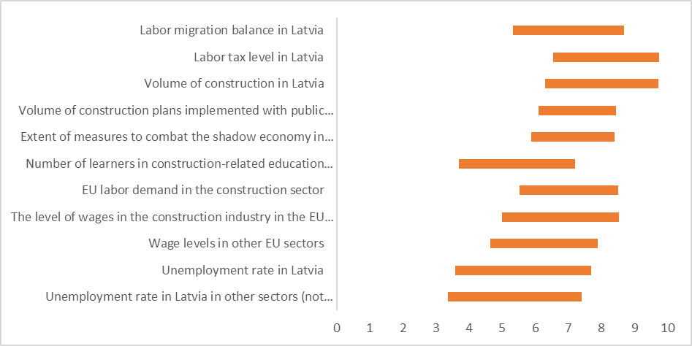
Fig. 2. Variation of the general expert assessments of the factors influencing labor costs around the average.
Assessing the differences in the opinions of general experts, it was found that the opinion of experts varies the most when assessing the unemployment rate both in Latvia as a whole and in other sectors. In this case, these factors coincide with those that were also assessed as the least influential. This variation is due to the fact that a very small number of experts have given a very high rating to these factors, but most experts still consider them to be insignificant. In turn, the greatest consensus of experts can be found in the factors: the amount of construction plans implemented with public funds; the amount of measures to combat the shadow economy in Latvia; EU labor demand in the construction sector. These factors were mentioned as moderately significant factors influencing labor costs, which shows that the impact of these factors is plausible, most experts acknowledge.
The second question asked general experts to assess the impact of various factors on the cost of building materials in the construction industry. The considered factors cover various areas, both at the Latvian and EU level. Analyzing the obtained expert answers, the average expert rating, median and fashion average expert rating, expert evaluation standard deviation and coefficient of variation were calculated (Table 7). Factors were rated on a 10-point scale, where a higher score means that the factor is a more significant factor influencing the cost of building materials in construction.
Table 7.
Statistical indicators characterizing the expert assessments of the general experts of the factors influencing the changes in the costs of construction materials.
Factors influencing changes in construction material costs | Average expert evaluation | Median of expert assessments | Modal expert assessment | Standard deviation of expert assessments
- Volume of construction in Latvia | 8,06 | 9 | 9 | 1,64
- Volume of construction plans implemented with public funds | 6,87 | 7 | 8 | 2,00
- Changes in gross domestic product in Latvia | 6,94 | 6,5 | 6 | 1,43
- Real estate lending volumes in Latvia | 6,75 | 7,5 | 8 | 1,79
- Indicators of competition concentration in the building materials market in Latvia | 6,69 | 7 | 7 | 1,21
- Number of construction plans in Latvia | 6,56 | 7 | 9 | 2,55
- EU economic growth rates | 6,56 | 6,5 | 5 | 1,80
- Total EU construction market demand | 6,38 | 6 | 6 | 1,87
- Extent of measures to combat the shadow economy in Latvia | 6,07 | 6 | 7 | 1,61
- The average fuel price in Latvia | 5,94 | 6 | 7 | 1,82
- Technical requirements for the quality of construction of EU buildings | 5,88 | 6,5 | 7 | 2,06
- Natural resources tax rate in Latvia | 5,20 | 5 | 5 | 1,90
- Average annual electricity price in Latvia | 5,06 | 5 | 7 | 2,30

The obtained results show that according to all indicators, the volume of construction in Latvia is considered to be the most important factor influencing labor costs in the construction sector.
Summarizing according to various statistical indicators (arithmetic mean, median, mode), the four most important factors that most influence the cost of building materials in the construction industry, according to experts, are (with the average expert score in points):
1. volume of construction in Latvia (8.06);
2. the amount of construction plans implemented with public funds (6.87);
3. changes in gross domestic product in Latvia (6.94);
4. real estate lending volumes in Latvia (6.75).
In turn, summarizing the factors that have the lowest evaluators, the experts generally indicated that the least important factors were:
• average fuel price in Latvia (5.94);
• EU technical requirements for construction quality of buildings (5.88);
• natural resources tax rate in Latvia (5.20);
• average annual electricity price in Latvia (5.06).
In order to assess the differences of experts' opinions, the amplitude of the standard deviation of expert evaluations around the average expert evaluation was considered (Fig. 3).

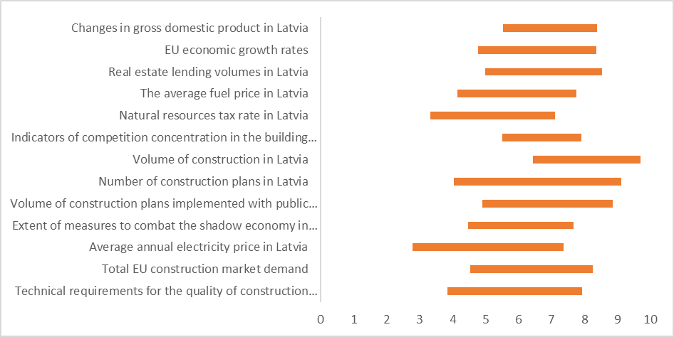
Fig. 3. Variation of the general expert assessments of the factors influencing the cost of construction materials around the average.
Assessing the differences in the opinions of general experts, it was found that the opinion of experts varies the most when assessing the number of construction plans in Latvia, the average annual electricity price in Latvia and the technical requirements for the quality of construction of EU buildings. Among these factors, there are none that are generally considered to be significant influencing factors, as a very small number of experts have given a very high rating to these factors, but most experts still consider them to be insignificant. In turn, the greatest consensus of experts can be found on the factors: changes in gross domestic product in Latvia; competition concentration indicators in the construction materials market in Latvia; the amount of measures to combat the shadow economy in Latvia. Among these factors, the most significant factor influencing labor costs is competition concentration in the building materials market in Latvia, which shows that the impact of these factors is plausible, acknowledged by most experts. The other factors are moderately influential.

Assessment of factors influence by sub-sector experts

Following the assessments of the general experts in Phase 1, in Phase 2 the sub-sectoral experts assessed the same influencing factors in the examination. Subsector experts assessed 11 factors that could influence changes in labor costs.
Table 8.
Statistical indicators characterizing expert assessments of factors influencing changes in labor costs.
Factors influencing changes in labor costs | Average expert evaluation | Median of expert assessments | Modal expert assessment | Standard deviation of expert assessments
- Labor tax level in Latvia | 7,86 | 8 | 8 | 2,26
- Volume of construction in Latvia | 7,57 | 8 | 9 | 1,90
- The level of labor wages in the EU countries in the construction sector | 7,20 | 8 | 8 | 1,83
- EU labor demand in the construction sector | 6,74 | 7 | 7 | 1,71
- Labor migration balance in Latvia | 6,68 | 7 | 8 | 2,05
- The amount of construction plans implemented with public funds | 6,57 | 7 | 6 | 1,95
- Extent of measures to combat the shadow economy in Latvia | 6,38 | 6,5 | 8 | 2,41
- Wage levels in other EU sectors | 6,00 | 6 | 7 | 1,99
- Unemployment rate in Latvia | 5,71 | 6 | 6 | 2,22
- Number of learners in construction-related education programs in Latvia | 5,57 | 6 | 7 | 1,93
- Unemployment rate in Latvia in other sectors (not construction) | 5,00 | 5 | 6 | 2,33

According to the assessments of sub-sector experts, the dominant influencing factor that causes the most changes in construction labor costs is the level of labor taxes in Latvia, which was assessed with an average of 7.86 points. According to the experts of the 2nd stage sub-sector entrepreneurs, the next most important factors are the volume of construction in Latvia (on average 7.57 points) and the level of labor wages in the EU countries in the construction sector (on average 7.20 points).
Based on the results of a survey of subcontracting experts, the three most important factors influencing labor costs in the construction industry can be identified:
1. level of labor taxes in Latvia (7.86);
2. volume of construction in Latvia (7.57);
3. level of labor wages in the EU countries in the construction sector (7.20).
Accordingly, the survey of Phase 2 sub-sector experts assessed thirteen key factors, which were also assessed in the survey of Phase 1 general experts.
Table 9.
Statistical indicators characterizing the expert assessments of the sub-sectors of the factors influencing the changes in the costs of construction materials.
Factors influencing changes in construction material costs | Average expert evaluation | Median of expert assessments | Modal expert assessment | Standard deviation of expert assessments
- Volume of construction in Latvia | 8,03 | 8 | 8 | 1,38
- Total EU construction market demand | 7,18 | 8 | 8 | 1,64
- The average fuel price in Latvia | 6,91 | 7 | 6 | 2,06
- Indicators of competition concentration in the building materials market in Latvia | 6,85 | 7 | 7 | 1,91
- Growth rates of the EU economy | 6,79 | 7 | 7 | 1,55
- Technical requirements for the quality of construction of EU buildings | 6,62 | 7 | 7 | 1,73
- Real estate lending volumes in Latvia | 6,56 | 7 | 6 | 1,87
- The amount of construction plans implemented with public funds | 6,50 | 7 | 8 | 1,77
- Average annual electricity price in Latvia | 6,35 | 7 | 7 | 2,11
- Changes in gross domestic product in Latvia | 6,33 | 6 | 6 | 1,61
- Number of construction plans in Latvia | 6,32 | 6 | 6 | 1,74
- Natural resources tax rate in Latvia | 6,03 | 6 | 7 | 2,27
- Extent of measures to combat the shadow economy in Latvia | 5,68 | 5,5 | 5 | 2,03

Further evaluating the previously selected key factors that affect the changes in the cost of construction materials in the construction industry as a whole, the experts of the 2nd stage recognized the volume of construction in the country with 8.03 points, followed by the total EU construction market demand with 7.18 points.
Based on the results of a survey of sub-sector experts, the three most important factors influencing the cost of construction materials in the entire construction industry can be identified:
1. volume of construction in Latvia (8.03);
2. Total EU construction market demand (7.18);
3. average fuel price in Latvia (6.91)

Assessment of factors influencing labor and construction material costs by sub-sectors

In each of the sub-sectors studied, the experts also assessed and identified individual factors that directly affect the sub-sector they represent, not just the overall construction sector.
The factors influencing labor costs in the residential and non-residential building construction sub-sector were assessed by experts in a wider range than other factors. A significant leader in the impact of labor costs is the volume of construction in Latvia with a rating of 8.22 points. On average, experts assessed the share of the population in occupations related to vocational education in construction (6.22 points) and the level of labor wages in Latvia in other sectors (5.78 points) as insignificant. It should be noted that in the assessment of the last factor there was a great disagreement of experts with a high standard deviation of expert assessments (2.44 points), therefore the average assessment of this factor should be perceived as less reliable..
Table 10.
Expert assessments of residential and non-residential building construction sub-sector on factors influencing labor costs.
Factors directly affecting the residential and non - residential buildings sub – sector | Average expert evaluation | Standard deviation of expert assessments
Proportion of population with vocational education in construction - related professions | 6,22 | 1,62
Volume of construction in Latvia | 8,22 | 1,23
Resources available to the population (own / banks, etc.) | 7,56 | 1,34
Labor wage level in Latvia in other sectors (not construction) | 5,78 | 2,44

When assessing the factors that affect the cost of building materials, the factor estimates are in a narrower range than when assessing the impact on labor costs. The volume of construction in the country that has the greatest (8.22 points) influence on the cost of construction materials was also assessed as the most important factor. The impact of other factors is assessed on average with the lowest assessment of changes in GDP in the country with 6.67 points.

Table 11.
Expert assessments of residential and non-residential building construction sub-sector on factors influencing the cost of construction materials.
Factors directly affecting the residential and non - residential buildings sub – sector | Average expert evaluation | Standard deviation of expert assessments
Volume of construction in the country | 8,22 | 1,23
Real estate lending volumes in the country | 7,78 | 1,75
Resources available to the population (own / bank, etc.) | 7,78 | 1,31
Changes in gross domestic product in the country | 6,67 | 0,94

The only individual comment on the significant impact of other factors on labor costs from experts directly in the construction of residential and non-residential buildings was:
"The extent of measures to combat the shadow economy in Latvia".

Factors influencing labor costs in the transport facilities construction sub-sector, which were assessed by experts, were directly related to the specifics of transport facilities.

Table 12.
Expert assessments of transport facilities construction sub-sector on factors influencing labor costs.
Factors influencing the transport construction sub-sector | Average expert evaluation | Standard deviation of expert assessments
Unpredictable amount of funding in the long and medium term (both in the national road network and in the municipality | 8,36 | 1,67
Uneven attraction / planning / use of EU funds in the construction sector within the programming period | 8,64 | 1,15
Rail Baltica project progress | 7,91 | 1,38

All the proposed factors were assessed as very significant influences that could have an impact on labor costs. The highest impact was assessed on the uneven attraction, planning and use of EU funds, which was assessed with an average score of 8.64 points. In the case of all evaluations, the opinions of the experts were relatively homogeneous and there were no significant disagreements, as evidenced by the standard deviation values ​​of the expert evaluations, which do not exceed two points.
Some expert statements on the factors influencing the cost of labor and construction materials:
"One year planning period in municipalities / MoU with maximum construction work in summer and downtime in winter."
"Inexpensive, low-quality, but paper-based materials."
The factors influencing the cost of construction materials in the transport construction sub-sector mentioned by the experts were assessed to a similar extent. All factors were assessed as significant, highlighting as the most significant uneven amounts of funding to be acquired in a given period.
Table 13.
Expert assessments of transport facilities construction sub-sector on factors influencing the cost of construction materials.
Factors influencing the transport construction sub-sector | Average expert evaluation | Standard deviation of expert assessments
The use of available funding is not coordinated, the amount of funding to be acquired is uneven in a specific period of time | 8,55 | 0,78
Volume of construction plans implemented with public funds | 7,64 | 1,07
Average fuel price in the country and changes in world oil prices | 7,18 | 1,53
Volume of construction output in the country | 7,55 | 0,99
Geographical availability of construction materials in the vicinity of construction sites | 7,27 | 1,96

An even greater degree of consensus was appreciated on this issue.

Factors influencing labor costs in the sub-sector of construction of urban infrastructure objects were assessed by analyzing four main factors that would have a direct impact in the field of urban infrastructure.
Table 14.
Experts' assessments of the sub-sector of construction of urban infrastructure objects on the factors influencing labor costs.
Factors influencing the construction sub-sector of urban infrastructure objects | Average expert evaluation | Standard deviation of expert assessments
Shortage of labor | 7,86 | 1,46
Volume of construction plans implemented with public funds | 6,86 | 2,23
Volume of construction output in Latvia | 6,00 | 2,14
The level of wages in the construction industry in the EU countries | 6,57 | 1,84

Compared to the representatives of other sub-sectors, lower expert evaluations are observed in the sub-sector of urban infrastructure construction. When assessing the impact of various factors directly on the labor and construction material costs of this sub-sector, the average estimates do not exceed eight points.
The most important factor influencing labor costs is the labor shortage with 7.86 points. All other factors are rated below 7 points as moderately significant.
Table 15.
Expert assessments of the construction sub-sector of urban infrastructure objects on the factors influencing the cost of construction materials.
Factors influencing the construction sub-sector of urban infrastructure objects | Average expert evaluation | Standard deviation of expert assessments
Volume of construction plans implemented with public funds | 6,71 | 1,67
Volume of construction output in the country | 6,86 | 1,73
The average price of fuel in the country, rising prices of oil products, the price of electricity | 6,86 | 1,64
Availability and price level of steel pipes and fittings on the EU market | 7,43 | 1,50
Availability of technological equipment, delivery time and price level in the EU market | 7,29 | 1,28

The availability and price level of steel pipes and fittings in the EU market (7.43 points) and the availability of technological equipment in the EU market (7.29 points) were assessed as the most significant factors influencing the changes in construction material costs in the sub-sector of urban infrastructure construction.

Factors influencing labor costs in the other civil engineering sub-sectors included both the volume of construction and a number of labor-related factors.
Table 16.
Expert assessments of other civil engineering construction sub-sector on factors influencing labor costs.
Factors influencing the rest of the civil engineering sub - sector | Average expert evaluation | Standard deviation of expert assessments
Volume of construction output in Latvia | 7,18 | 2,41
Labor tax level in Latvia | 7,00 | 3,16
Proportion of skilled labor with education / experience in other civil engineering sub-sectors | 7,25 | 2,22
Increasing competition between employers for skilled labor in the labor market | 7,25 | 2,44

Among other engineering construction experts, very similar average ratings were observed for the bidding factors with an average rating range of only 0.25 points. At the same time, this block had the highest heterogeneity of expert opinions with high standard deviations of expert assessments, which indicates a large dispersion of opinions. Consequently, one factor cannot be considered to be more important than others and the significance of all of them can be assessed as moderately high.
Table 17.
Expert assessments of other civil engineering construction sub-sector on factors influencing the cost of construction materials.
Factors influencing the rest of the civil engineering sub - sector | Average expert evaluation | Standard deviation of expert assessments
Labor availability | 6,63 | 1,87
Volume of construction output in the country | 8,13 | 1,83
Fuel price | 5,63 | 2,50

In turn, when evaluating the factors that affect the cost of building materials, there is a wider variation. Experts assessed the volume of construction output in the country as the only factor with a high impact (8.13 points). However, factors such as fuel prices and labor availability have little effect.

Impact of measures to combat the shadow economy

The experts were asked to assess the impact of the measures planned and implemented by various state institutions to combat the shadow economy on the labor and construction costs of the construction industry. Analyzing the obtained answers of both general and sub-sectoral experts, the average expert assessment, median and fashion average expert assessment, standard deviation of expert assessments were calculated (Table 18). The impact of measures to combat the shadow economy on construction costs was assessed on a scale of -10 to +10 points, where a higher score means that the factor of combating the shadow economy significantly increases or decreases the cost of labor or construction materials in construction..

Table 18.
Statistical indicators characterizing expert assessments of the impact of measures to combat the shadow economy on labor costs.
Impact of measures to combat the shadow economy on labor costs | Average expert evaluation by general experts | Average expert evaluation by sub-sector experts | Overall average
Introduction of electronic working time accounting system, incl. data transfer VEDLUDB. | 5,21 | 4,97 | 5,04
Lowering the threshold for the implementation of the EDLUS system (labor costs from 350,000 EUR and more). | 3,54 | 3,69 | 3,64
Introduction of administrative responsibility in construction from July 1, 2020. | 3,71 | 3,58 | 3,62
Entry into force of the General Agreement on the Minimum Wage in the Construction Sector. | 5,13 | 4,32 | 4,57

Assessing the impact of shadow economy measures on labor costs, the average assessment of all measures is positive. Only one general stage expert and six sub-sectoral stage experts gave some negative assessments that the measures would reduce costs. However, most experts, as well as all aggregates, are non-negative, which means that, in general, experts believe that all measures will increase labor costs in the construction sector.
As the most important factors, the experts assessed the introduction of the electronic working time accounting system and the entry into force of the general agreement on the minimum wage in the construction industry. For all other measures, most experts did not attach importance on average - they are not expected to have a significant impact on costs.
Table 19.
Statistical indicators characterizing expert assessments of the impact of measures to combat the shadow economy on the cost of construction materials.
Impact of measures to combat the shadow economy on the cost of building materials | Average expert evaluation by general experts | Average expert evaluation by sub-sector experts | Overall average
Introduction of electronic working time accounting system, incl. data transfer VEDLUDB. | 1,54 | 1,71 | 1,67
Lowering the threshold for the implementation of the EDLUS system (labor costs from 350,000 EUR and more). | 0,92 | 1,76 | 1,52
Introduction of administrative responsibility in construction from July 1, 2020. | 1,62 | 1,59 | 1,60
Entry into force of the General Agreement on the Minimum Wage in the Construction Sector. | 1,07 | 1,63 | 1,47

Assessing the impact of shadow economy measures on the cost of building materials, the average assessment of all measures is also positive (Table 19). No general phase expert and only two sub-sectoral phase experts gave some negative assessments that the measures would reduce costs. However, the majority of experts and also all the aggregate indicators are non-negative, which means that in general, experts believe that all measures will increase the cost of building materials in the construction industry, but very insignificant.
The impact of all measures is poorly assessed - out of 10 points, the average evaluation of any measure does not exceed 2 points, if, in comparison, the average expert evaluation of labor costs in two evaluations exceeded 5 points. Experts consider the introduction of administrative responsibility in construction from July 1, 2020 and the introduction of electronic working time accounting system as the most important factors. For all other measures, most experts did not attach importance on average - they are not expected to have a significant impact on costs.

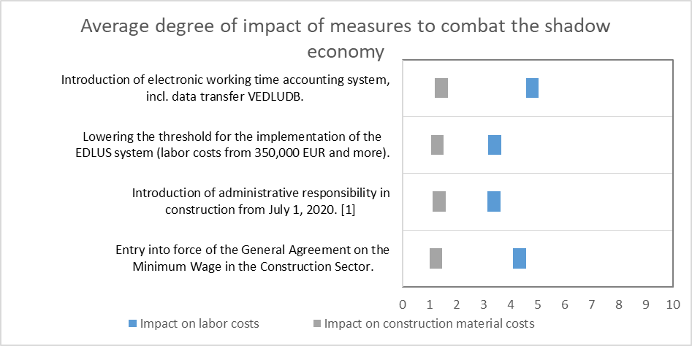
Fig. 4. Average degree of impact of measures to combat the shadow economy on labor and construction material costs according to the average expert assessment,
In general, according to experts, the planned and implemented measures to combat the shadow economy have a significantly more significant impact on labor costs than the costs of construction materials (Fig. 4). When evaluating electronic working time accounting, the average estimate is three times higher for the impact on labor costs than for construction material costs. There are no significant differences between the other measures.
Comparing the assessments provided by general experts and sub-sector experts, no significant differences of opinion are generally observed. However, there are discrepancies in the assessment of the lowering of the EDLUS system implementation threshold and the costs of construction materials. General experts rated the impact on average as 0.92, while sub-sector experts rated it much higher at 1.76 points. Similarly, the general agreement in the construction sector was assessed by general experts as less influential on the cost of construction materials (1.07 points), but by sub-sectoral experts as more influential (1.63 points). Overall, there is a tendency for general experts to rate the impact of measures to combat the informal economy on labor costs slightly higher than for sub-sectoral experts. On the other hand, sub-sector experts rate the impact of measures to combat the shadow economy on the cost of building materials higher than general experts..

Impact of COVID-19 on the construction industry

During the study, a pandemic of COVID-19 virus had started both in Latvia and all over the world. Both the disease itself and the measures taken to combat it have led to a significant slowdown in the world economy and a recession in many countries. In Latvia, too, most sectors of the economy entered a downturn, although the construction sector was one of the least affected. The study also assessed the consequences and impact of the COVID-19 pandemic on the costs of the construction industry as a whole.
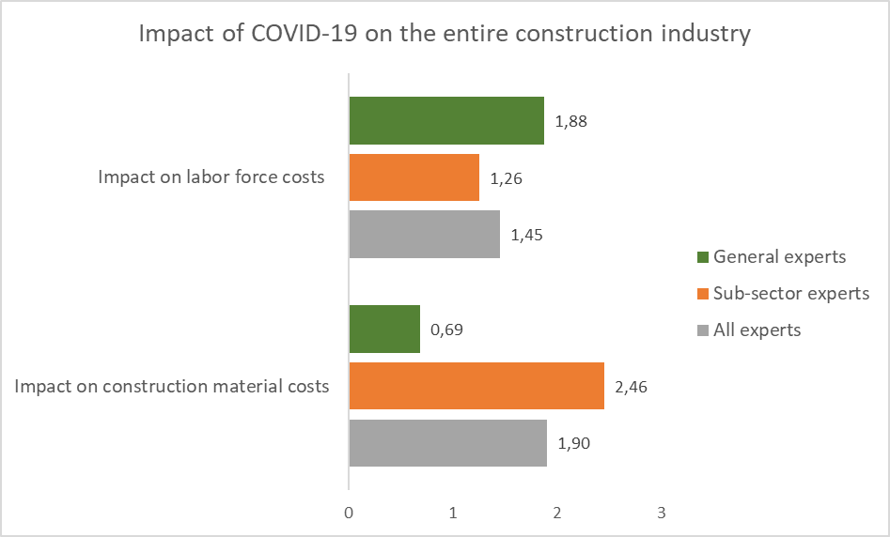
Fig. 5. COVID-19 the average degree of impact of the pandemic on labor and construction material costs according to the average expert assessment in the period until 20204
Overall, the results show that the surveyed experts do not see a significant impact on construction costs. Individual expert opinions shared both positive and negative evaluations. Of all experts, 20.3% believed that labor costs could decrease, and 15.7% believed that the cost of construction materials could decrease. However, most experts considered that COVID-19 would have a moderately cost-increasing effect.
On average, a larger impact of the pandemic on construction material costs is projected. On a scale of up to 10 points, the average score is 1.9 points, which indicates a low degree of impact. Admittedly, sub-sectoral experts saw a higher degree of influence (2.46 points) than general experts (0.69 points). For the impact on labor costs, an even lower degree of influence is indicated - 1.45 points. Thus, it can be assumed that, on average, experts do not see a significant cost impact of a pandemic.

Forecast of changes in the volume and cost of construction output

Total changes in the volume and costs of construction output

The experts provided a direct forecast, assessing the expected amount of changes in the volume of construction output and construction costs for the period from 2020 to 2024, respectively. Summarizing the forecasts provided by the experts, the average expert assessment and the standard error of expert assessments for each forecasted year were obtained. In order to assess the variation of expert opinions in each year, the positive and negative deviation in the amount of standard deviation from the average expert forecast was calculated.
When forecasting changes in the volume of construction output, the average expert assessment indicates a moderate increase in the volume of construction output in 2020, after which an ever-higher annual growth is forecast on average for all subsequent years, reaching the lowest level in 2024.

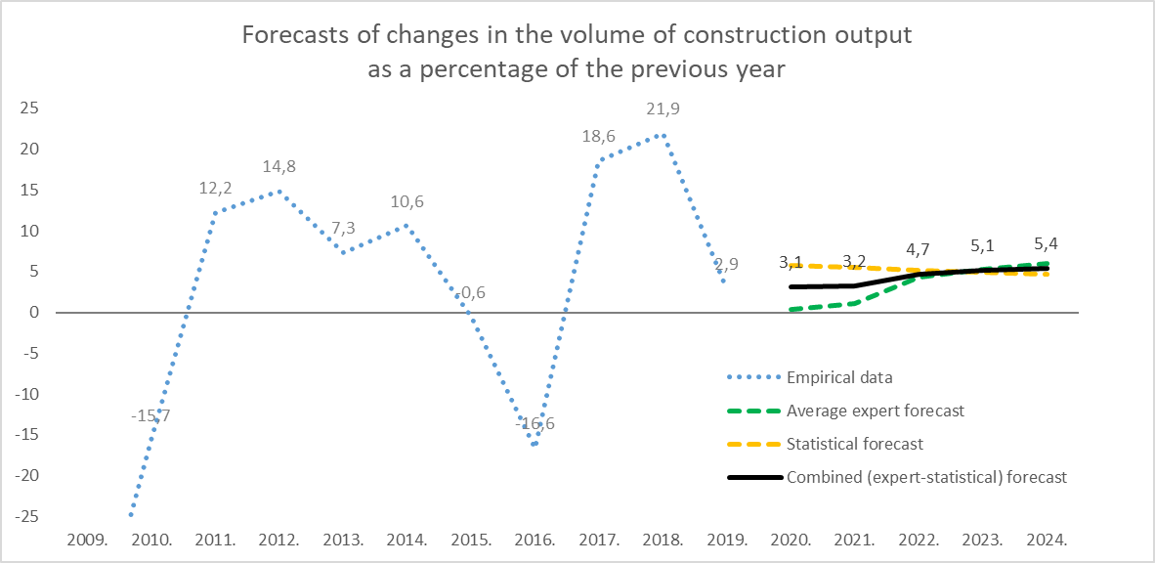
Fig. 6. Expert forecasts of changes in the volume of construction output for 2020-2024.
When forecasting changes in the volume of construction output, the forecasts provided by experts gradually increase throughout the period from 2020 to 2024 (Fig. 6). The observed standard deviation of expert assessments is between 3.25 and 5.57 percentage points, which in the context of the obtained forecasts indicates a relatively unequal view of future developments in the construction sector. In the opinion of general experts, amplitudes were observed, some experts also predicted a decrease in the volume of production. However, most considered that moderate growth would be expected, which can also be seen in the average expert estimates obtained.
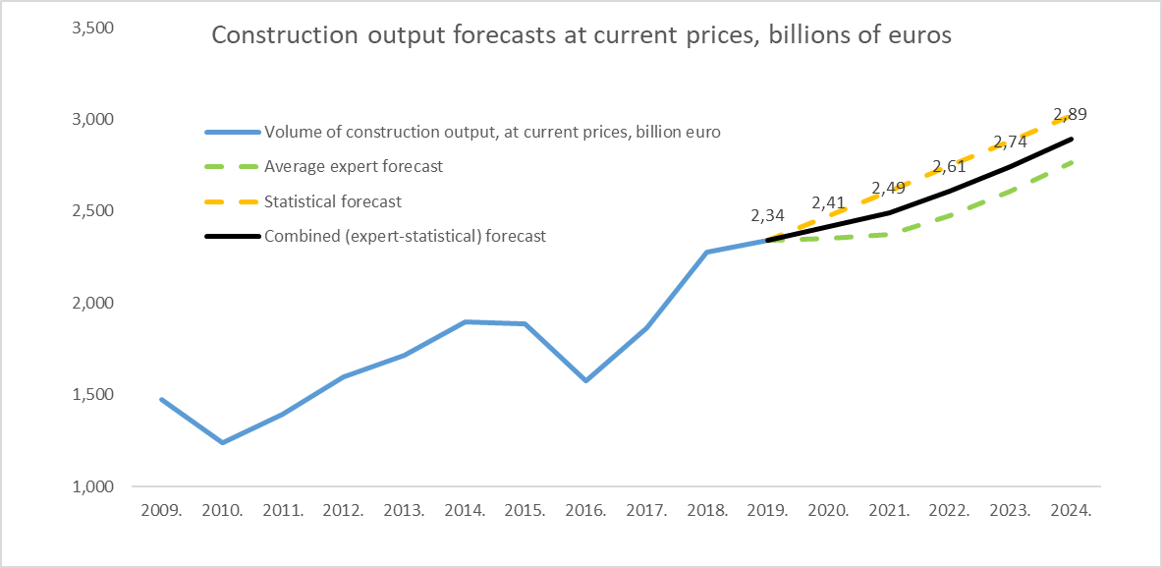
Fig. 7. Construction output at current prices based on expert and combined forecasts for 2020-2024.

The combined (expert-statistical) forecast differs significantly from the expert assessment. This difference is largely related to the trends of previous years. In the period from 2009 onwards, after the crisis in the construction sector as a whole, market growth was observed, which, of course, was not stable. It was characterized by cyclical fluctuations with negative and positive growth. Given this trend, the statistical forecast is also on an upward trend. In 2020, growth in construction output is expected to be minimal due to the global and national recession caused by the COVID-19 pandemic. Such extremely rare events (a pandemic a few times a century) are difficult to statistically model using key trend indicators. Therefore, the average expert forecasts would be considered more reliable, as the experts took into account the pandemic effect in their assessments.
When forecasting changes in construction costs, experts predict a moderate increase in costs in 2020-2021, which would be followed by a faster jump in 2022-2024 (Fig. 7).

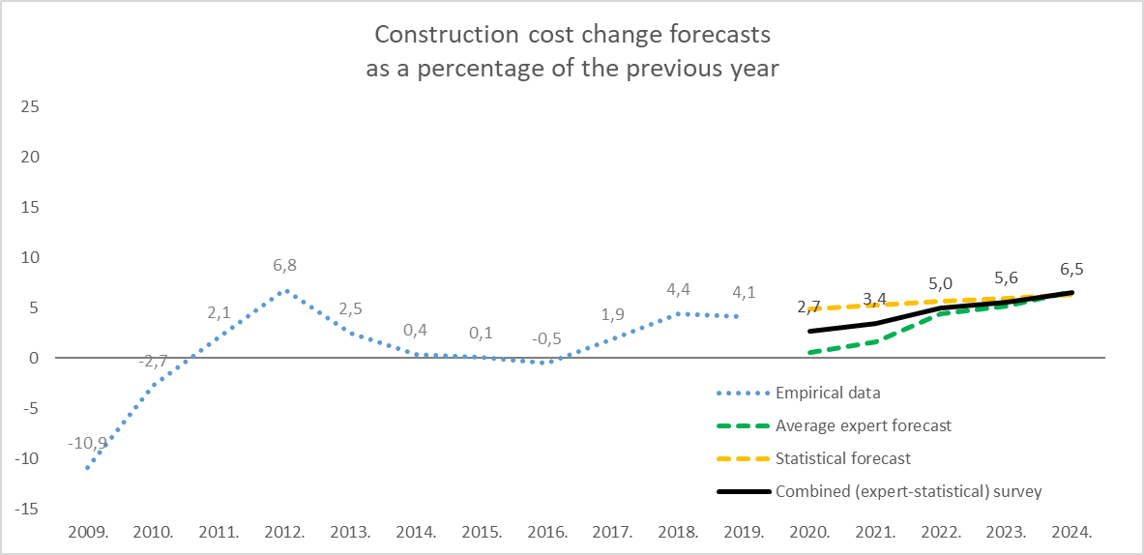
Fig. 8. Construction cost change expert forecasts for 2020-2024.

Unlike changes in the volume of construction output, forecasts of changes in construction costs are more consistent - both the average forecasts of experts and the combined (expert-statistical) forecast do not differ significantly for the period 2022-2024. year. There are differences between 2020 and 2021. year forecasts, where expert forecasts are more down to earth. This can be explained by the fact that the results of statistical forecasts are affected by 2017-2019. The constant increase of costs in 2007, which as a result of extrapolation is continued in the following periods as well.
Table 20.
Changes in the volume and costs of construction output until 2017 and average expert forecasts from 2018 to 2022.
2015. | 2016. | 2017. | 2018. | 2019. | 2020. | 2021. | 2022. | 2023. | 2024.
Percentage change in construction output compared to the previous year
-0,6% | -6,6% | +18,6% | +21,9% | +2,9% | Average expert forecast
 |  |  |  |  | +0,41% | +1,04% | +4,26% | +5,27% | +6,05%
 |  |  |  |  | Combined (expert-statistical) forecast
 |  |  |  |  | +3,07% | +3,25% | +4,72% | +5,11% | +5,38%
Percentage change in construction costs compared to the previous year
+0,1% | -0,5% | +1,9% | +4,4% | +4,1% | Average expert forecast
 |  |  |  |  | +0,55% | +1,58% | +4,39% | +5,17% | +6,62%
 |  |  |  |  | Combined (expert-statistical) forecast
 |  |  |  |  | +2,69% | +3,41% | +5,01% | +5,57% | +6,46%

By looking at the effect of average changes in construction output on changes in costs, the effect of one percentage point change in the volume of each construction output on changes in costs can be assessed. In the period under review from 2015 to 2018, each percentage point of the increase in construction output on average increased the change in costs by 0.10 percentage points. In turn, in the period of 2020-2024 forecasted by experts, each percentage point of construction output growth would cause an average change in costs by 0.99 percentage points. Using the results of combined (expert-statistical) forecasts, each percentage point of construction output growth would cause an average cost change of 0.65 percentage points.
In addition to changes in costs in the overall construction industry, general experts assessed changes in costs by type of resource. Four types of resources were identified:
1. Changes in construction material costs;
2. Changes in workers' wage costs;
3. Changes in maintenance and operating costs of machines and mechanisms;
4. Architectural and engineering services; changes in the costs of technical inspection and analysis.

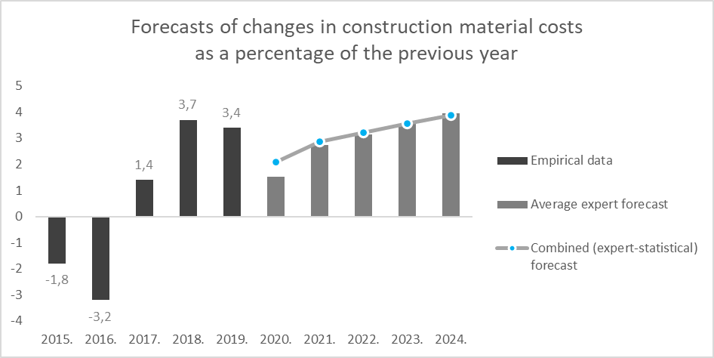
Fig. 9. Expert forecasts of changes in construction material costs for 2020-2024.

When forecasting changes in the costs of construction materials, the average assessment of experts envisages an increase in costs in 2020 by 1.51% compared to the previous year (Fig. 8). In the coming years, experts predict an acceleration of cost growth, which will reach up to 3.96% in 2024.

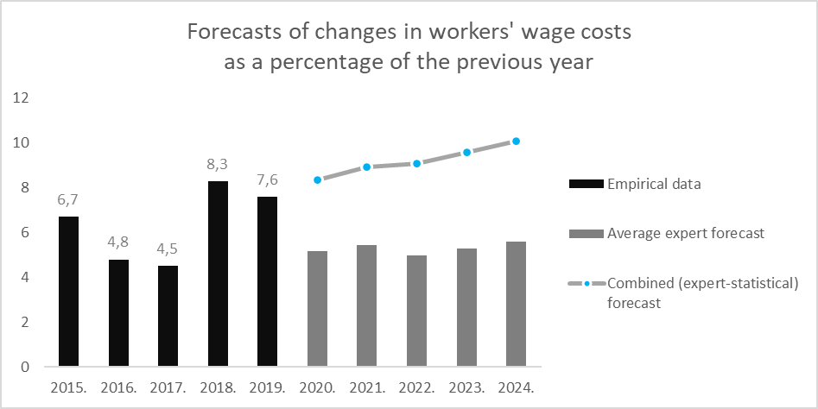
Fig. 10. Experts forecasts of changes in workers' wages for 2020-2024.
Changes in workers' wages are the position in which, of all four types of resources, experts predict the fastest increase in costs (Fig. 9). In 2020, a cost increase of 5.16% is forecast. In all other years of the period under review, the experts' forecasts fluctuate in the range of 4-5% with the lowest forecast increasing by 4.97% in 2022 and the highest forecast by 5.59% in 2024.
According to experts, changes in the maintenance and operation costs of machines and mechanisms will increase the least in 2020 (Fig. 10)..

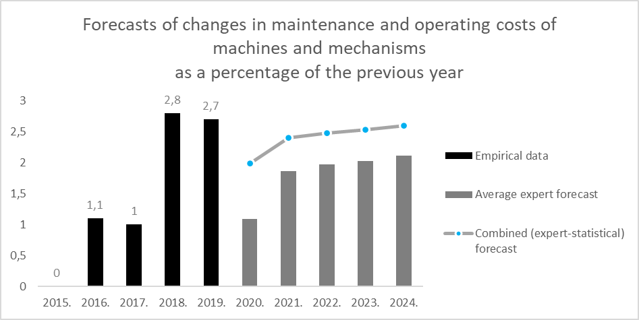
Fig. 11. Expert forecasts of changes in maintenance and operation costs of machines and mechanisms for 2020-2024.
The projected increase is 1.09% compared to the previous year. This is the only type of resource for which experts predict, on average, a stable change between 2020 and 2024, with cost changes rising just above 2%. In subsequent periods - in 2023 and 2024, the costs of machinery and mechanisms will continue to increase on average by 2.03% and 2.11%.

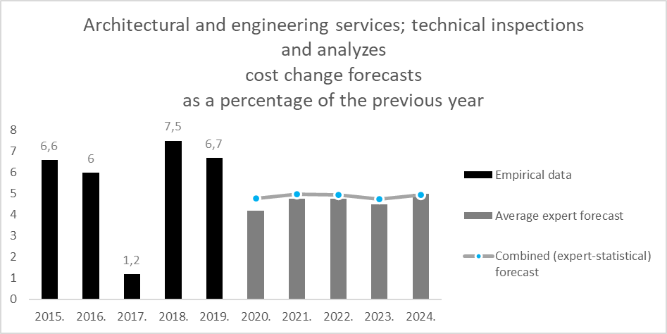
Fig. 12. Experts' forecasts of changes in technical inspection and analysis of architectural and engineering services for 2020-2024.
Forecasting architectural and engineering services; changes in the costs of technical inspection and analysis, the average forecast of experts in 2020 reaches 4.21%, in the following years gradually increasing in 2024 reaching 4.98% per year (Fig. 11.).
Table 21.
Changes in construction costs until 2019 and average expert forecasts from 2020 to 2024 by types of resources.
2015. | 2016. | 2017. | 2018. | 2019. | 2020. | 2021. | 2022. | 2023. | 2024.
Changes in construction material costs
-1,8% | -3,2% | +1,4% | +3,7% | +3,4% | Average expert forecast
 |  |  |  |  | +1,51% | +2,74% | +3,14% | +3,54% | +3,96%
 |  |  |  |  | Combined (expert-statistical) forecast
 |  |  |  |  | +2,09% | +2,87% | +3,22% | +3,55% | +3,88%
Changes in workers' wage costs
+6,7% | +4,8% | +4,5% | +8,3% | +7,6% | Average expert forecast
 |  |  |  |  | +5,16% | +5,45% | +4,97% | +5,30% | +5,59%
 |  |  |  |  | Combined (expert-statistical) forecast
 |  |  |  |  | +8,37% | +8,94% | +9,08% | +9,60% | +10,08%
Changes in maintenance and operating costs of machinery and equipment
+0,0% | +1,1% | +1,0% | +2,8% | +2,7% | Average expert forecast
 |  |  |  |  | +1,09% | +1,86% | +1,97% | +2,03% | +2,11%
 |  |  |  |  | Combined (expert-statistical) forecast
 |  |  |  |  | +1,99% | +2,40% | +2,48% | +2,53% | +2,60%
Architectural and engineering services; technical testing and analysis
+6,6% | +6,0% | +1,2% | +7,5% | +6,7% | Average expert forecast
 |  |  |  |  | +4,21% | +4,77% | +4,76% | +4,49% | +4,98%
 |  |  |  |  | Combined (expert-statistical) forecast
 |  |  |  |  | +4,76% | +4,98% | +4,93% | +4,75% | +4,95%

Summarizing the forecasts provided by experts (Table 21), the most rapid nature of cost changes is expected for wages, followed by the costs of architectural and engineering services - for those cost items that are more related to attracting labor. For all the types of resources considered, from 2020 to 2024, experts forecast an average higher percentage increase compared to the previous year, however, no reduction in costs is forecast for any heading and year.
In addition to the forecasting of the total industry, a survey of sub-industry experts was conducted, respectively, looking at the forecasted changes in construction output and costs by groups of objects and types of resources.
Assessing the changes in the construction output of the respective sub-sector in all sub-sectors, similar trends can be considered with decreasing initial periods and increasing recent periods (Table 22). According to experts, the fastest growth in 2020 is + 9.71% on average for the construction of bridges and tunnels, while a decline is forecast for the rest of civil engineering - 11.1%. In the period until 2024, in almost all sub-sectors, expert assessments become relatively homogeneous in different sub-sectors.
The period of 2021-2023 in railway construction is forecasted as a significant breakthrough with the annual volume of production changes forecasted at 19.25%, 55.75% and 30.75%, respectively. Of all the sub-sectors, this is the most significant projected increase.
Table 22.
Forecasts of changes in construction output as a percentage of the previous year according to the average assessment of sub-sector experts.
 | 2020. | 2021. | 2022. | 2023. | 2024.
Construction of residential buildings | -0,37 | -3,02 | +0,57 | +4,59 | +6,01
Construction of non - residential buildings | -1,46 | -2,26 | +0,31 | +2,23 | +2,23
Construction of roads and motorways | +6,25 | +3,50 | +9,38 | +7,50 | +4,38
Railway construction | +1,00 | +19,25 | +55,75 | +30,75 | +5,75
Construction of bridges and tunnels | +9,71 | +8,71 | +6,71 | +4,86 | +3,86
Construction of city infrastructure objects | -0,67 | +2,17 | +6,17 | +8,50 | +5,67
Other civil engineering | -11,10 | -0,49 | +10,40 | +4,89 | +8,60

In turn, summarizing the results on changes in construction costs (Table 23), the opinion of experts on the increase in costs from 2022 clearly dominates. Until then, there have been different directions of development in different sub-sectors. Experts see the highest increase in construction costs in the construction of railways, bridges and tunnels, where in some years an average of 6% and higher cost growth is forecast. Taking into account the slow growth of construction output, in 2020 in several sectors (residential, non-residential buildings, roads and highways) construction is projected to reduce costs. However, as early as 2022, experts in all sub-sectors forecast an increase in costs on average.
Table 23.
Forecasts of changes in construction costs as a percentage of the previous year according to the average assessment of sub-sector experts.
 | 2020. | 2021. | 2022. | 2023. | 2024.
Construction of residential buildings | -0,53 | +0,76 | +2,57 | +4,59 | +5,68
Construction of non - residential buildings | -1,23 | -0,26 | +2,64 | +3,90 | +4,01
Construction of roads and motorways | -8,50 | +0,13 | +2,50 | +4,50 | +6,88
Railway construction | +1,00 | +6,00 | +5,50 | +4,50 | +2,50
Construction of bridges and tunnels | +1,57 | +5,00 | +6,57 | +6,57 | +6,57
Construction of city infrastructure objects | +2,67 | +3,33 | +4,83 | +4,33 | +4,00
Other civil engineering | +0,71 | +4,97 | +4,10 | +4,26 | +5,11

Changes in construction costs by type of resource

Changes in construction costs by type of resource were assessed in each of the studied sub-sectors. In the residential sub-sector, the largest cost changes are projected for architectural and engineering services (Table 24), where average estimates range from 3.44% in 2021 to 6.67% in 2024, all of which are the highest estimates in the sub-sector among all resource types. The smallest cost changes are expected for the maintenance of machines and mechanisms.
Table 24.
Forecasts of changes in residential construction costs as a percentage of the previous year according to the average assessment of sub-sector experts by type of resources.
 | 2020. | 2021. | 2022. | 2023. | 2024.
Changes in construction material costs | -0,56 | 2,22 | 3,56 | 3,56 | 4,13
Changes in workers' wage costs | -0,56 | 3,44 | 3,56 | 4,22 | 1,78
Changes in maintenance and operating costs of machinery and equipment | -1,22 | 1,78 | 3,89 | 3,67 | 2,75
Architectural and engineering services; technical testing and analysis | -0,67 | 3,44 | 5,78 | 6,11 | 6,67

The general trend for all types of resources envisages a reduction in costs in 2020, followed by an increase in costs for all items from 2021 to 2023. In the 2024 assessment, lower cost growth rates are again possible for some items, such as wages and maintenance of machinery and equipment. In summary, compared to 2019, the fastest increase in costs in five years is forecasted for architectural and engineering services, where the total increase will reach 23.02%..

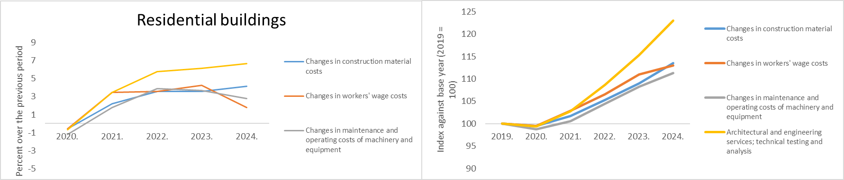
Fig. 13. Forecasts of changes in residential construction costs as a percentage of the previous year and in indices against 2019 according to the average assessment of sub-sector experts by types of resources.

In the non-residential building construction sub-sector, relatively similar trends are observed as in the residential building sub-sector (Table 25). This group is also dominated by architectural and engineering services, which is the fastest growing position from 2021 (3.78%) to 2024 (7.00%). Maintenance of machinery and equipment is a slower growing item, although workers' wages are projected to grow at a similarly low rate. For all headings in 2020, experts predict a reduction in costs, albeit relatively small, between 0.56% and 1.22% per year.
Table 25.
Forecasts of changes in construction costs of non-residential buildings as a percentage of the previous year according to the average assessment of sub-sector experts by type of resources.
 | 2020. | 2021. | 2022. | 2023. | 2024.
Changes in construction material costs | -0,56 | 2,33 | 4,11 | 3,56 | 4,22
Changes in workers' wage costs | -0,67 | 2,89 | 3,33 | 4,11 | 1,78
Changes in maintenance and operating costs of machinery and equipment | -1,22 | 2,33 | 3,89 | 3,67 | 2,75
Architectural and engineering services; technical testing and analysis | -0,89 | 3,78 | 5,33 | 6,11 | 7,00

All resource groups have projected cost reductions in 2020, followed by increases from 2021 to 2023. Further estimates In 2024, lower cost growth is projected for wages and maintenance of machinery and equipment, but it could continue to increase in other items. In general, the highest cost increase is forecast for architectural and engineering services, where costs could increase by 23.01% in five years..
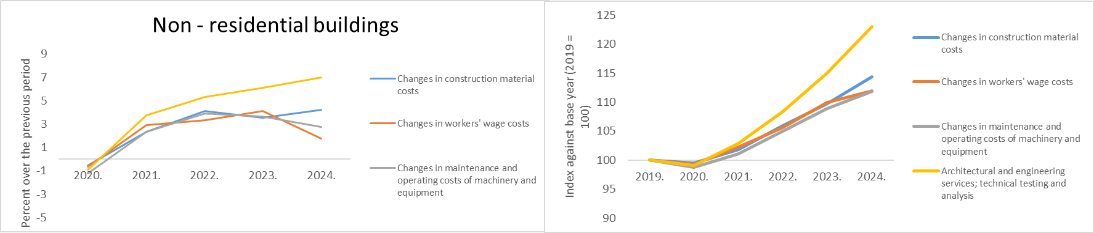
Fig. 14. Forecasts of changes in construction costs of non-residential buildings as a percentage of the previous year and in indices against 2019 according to the average assessment of sub-sector experts by types of resources.
In the construction of transport facilities by types of resources, an increase in costs is forecasted for all items (Table 26). However, in 2020, this growth rate is considered to be relatively insignificant, ranging between 0.64% and 1.55%. In general, the largest cost increase position in the construction of transport facilities is forecasted for workers' wages, where the highest assessment is given in 2023 with a 6.00% increase.
Table 26.
Forecasts of changes in construction costs of transport facilities as a percentage of the previous year according to the average assessment of sub-sector experts by type of resources.
 | 2020. | 2021. | 2022. | 2023. | 2024.
Changes in construction material costs | 1,55 | 4,68 | 2,91 | 2,45 | 2,70
Changes in workers' wage costs | 0,64 | 3,91 | 5,64 | 6,00 | 5,91
Changes in maintenance and operating costs of machinery and equipment | 1,45 | 3,36 | 2,91 | 4,55 | 4,64
Architectural and engineering services; technical testing and analysis | 1,55 | 4,00 | 6,27 | 5,91 | 3,55

Summarizing the forecasts over a five-year period, there are smaller differences between resource types in this sub-sector than in building construction. However, overall cost increases are estimated to be relatively high. For example, over five years, workers' wages are projected to increase by 19.95%.
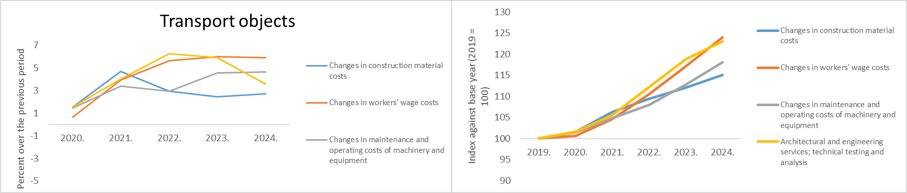
Fig. 15. Forecasts of changes in construction costs of transport facilities as a percentage of the previous year and in indices against 2019 according to the average assessment of sub-sector experts by types of resources.
In the sub-sector of construction of urban infrastructure objects, cost change forecasts increase by no more than 4.86% per year, which is relatively moderate compared to, for example, the transport sub-sector. In all positions, the average expert estimates predict an increase in costs. The lowest increase is expected in the cost of construction materials, which could increase from the lowest level of 2.00% in 2020 to an increase of 4.29% in 2024..
Table 27.
Forecasts of changes in construction costs of urban infrastructure objects as a percentage of the previous year according to the average assessment of sub-sector experts by type of resources.
 | 2020. | 2021. | 2022. | 2023. | 2024.
Changes in construction material costs | 1,86 | 2,86 | 3,29 | 2,86 | 3,57
Changes in workers' wage costs | 1,14 | 3,71 | 4,86 | 4,43 | 4,43
Changes in maintenance and operating costs of machinery and equipment | 1,86 | 2,71 | 3,29 | 3,29 | 3,43
Architectural and engineering services; technical testing and analysis | 2,00 | 3,43 | 3,43 | 3,86 | 4,29

The general trend in the sub-sector of urban infrastructure construction is aimed at an ever slower increase in costs until 2024. Overall, workers' wages are estimated to grow the most with a 19.95% increase over five years, and architectural and engineering services with an 18.18% increase over five years.
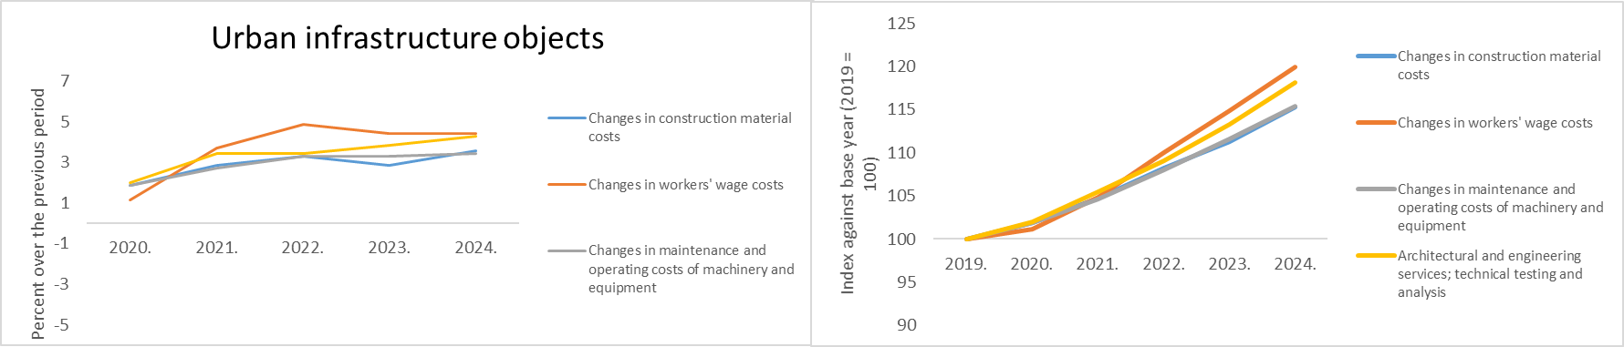
Fig. 16. Forecasts of changes in the construction costs of urban infrastructure objects as a percentage of the previous year and in indices against 2019 according to the average assessment of sub-sector experts by types of resources.
The rest of the civil engineering sub-sector has relatively high forecasts for service costs (Table 28), with the exception of workers' wages in 2020, which is the only period in which a cost reduction of 2.00% is forecast. The group of workers' wage resources also has the lowest growth rates on average. This is the only category where significant changes in the cost of machinery and equipment with a 12.66% increase in 2022 are foreseen.
Table 28.
Forecasts of changes in other civil engineering costs as a percentage of the previous year according to the average assessment of sub-sector experts by type of resources.
 | 2020. | 2021. | 2022. | 2023. | 2024.
Changes in construction material costs | 4,33 | 5,69 | 4,44 | 5,37 | 6,60
Changes in workers' wage costs | -2,00 | 4,29 | 6,11 | 7,81 | 7,39
Changes in maintenance and operating costs of machinery and equipment | 2,04 | 7,37 | 12,66 | 3,89 | 6,53
Architectural and engineering services; technical testing and analysis | 7,43 | 8,43 | 7,57 | 5,30 | 7,71

Other civil engineering is the sub-sector with the highest total projected cost increase. The costs of architectural and engineering services are under management, which could increase by 42.12% in five years. These are followed by the maintenance and operation costs of machinery and equipment, which could increase by a total of 36.6% in five years. In other items, too, the total cost increase exceeds the 20% mark.
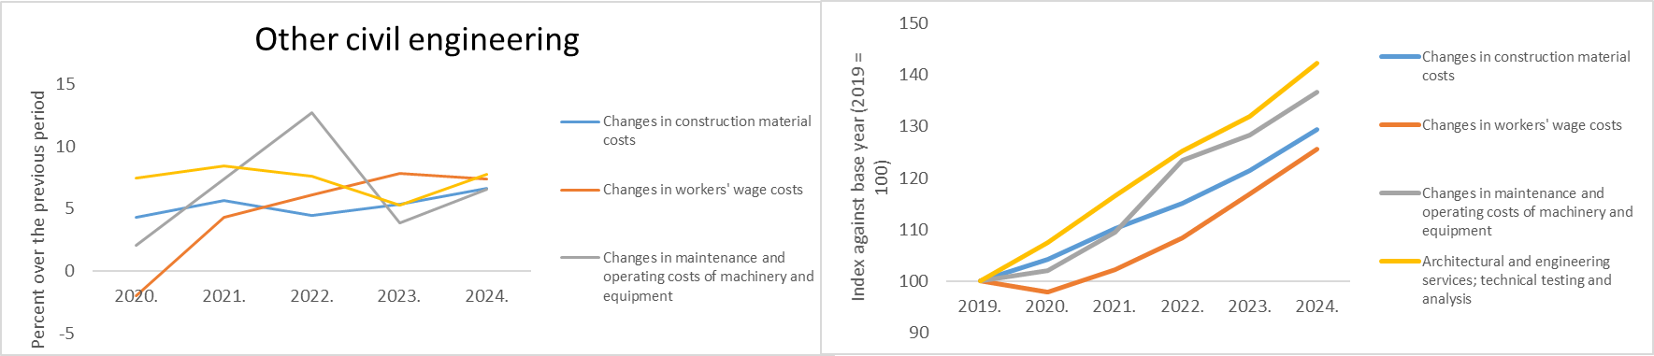
Fig. 17. Forecasts of changes in other civil engineering costs as a percentage of the previous year and in indices against 2019 according to the average assessment of sub-sector experts by types of resources.
In general, all positions and sub-sectors are characterized by the smallest increase or even decrease in costs in 2020. Between 2021 and 2023, cost increases will prevail, especially in the construction of railways, bridges and tunnels. In 2024, the overall trend is to reduce the rate of cost growth.

Impact of construction output on costs and industry average profit margin

The experts were introduced to the current average relationship between the pre-tax profit ratio of construction companies and turnover in order to assess the dependence of the profit margin on the volume of construction output.
Looking at the period from 2006 to 2019, there is a moderately strong correlation between changes in the volume of construction output in Latvia and changes in construction costs. There is a general correlation that in years with higher construction volume growth there is also a larger increase in costs and vice versa (Fig. 17)..
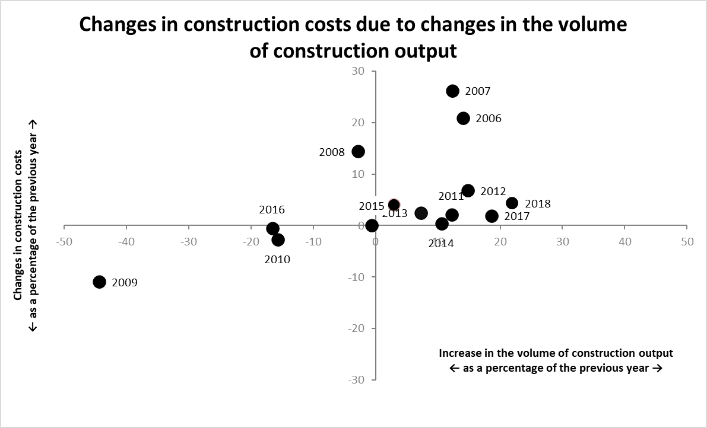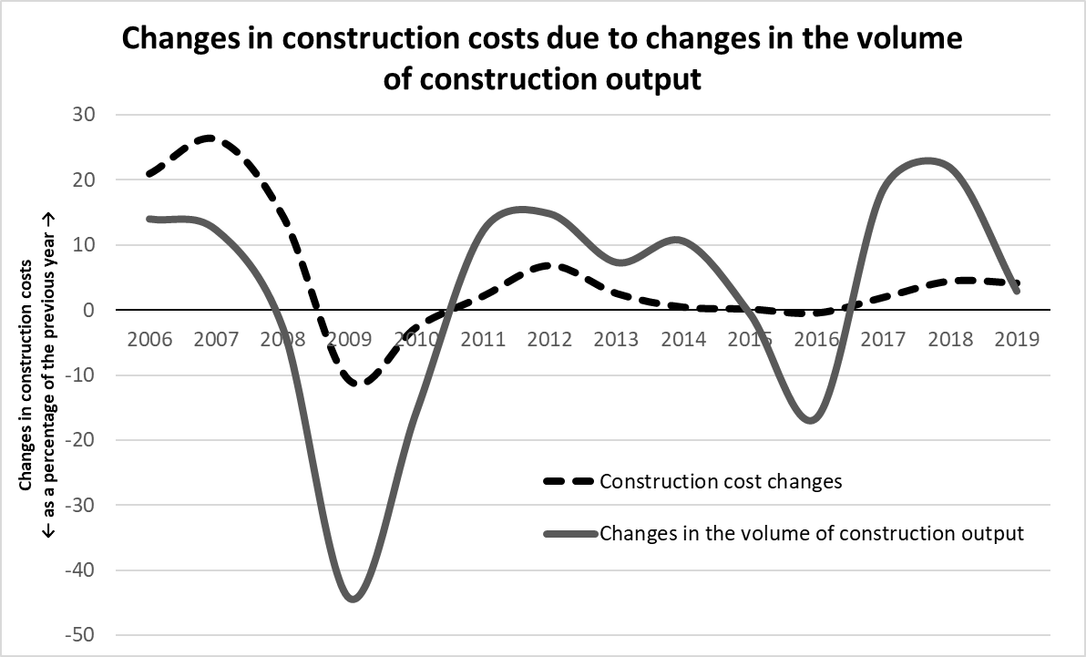
Fig. 18. Changes in the volume of construction output and construction costs from 2006 to 2019.

Looking at the total time period from 2006 to 2019, it is possible to determine the average relationship between changes in the volume of construction output and changes in construction costs. It can be seen that as construction output increases overall, so do construction costs. The average effect in the period under review is 0.298, which means that when the volume of construction output increases by one percentage point, construction costs increase on average by 0.298 percentage points and vice versa. This is also in line with the observed trend that, in general, the increase in construction costs is three times (3.36) less than the increase in construction output.
One of the research questions was about the acceptable profit margin of construction companies under different growth scenarios of the construction industry. In order to assess the past situation, data on the net turnover of merchants in the construction sector and the profit or loss of merchants after taxes in the construction sector by years were used. Taking into account that the CSB data are compiled on profit or loss after taxes and not before, it was also emphasized in the questions of experts that the profit margin used will be considered as the ratio of profit after taxes to turnover. Thus, it was obtained in the average situation among Latvian construction companies from 2006 to 2018. 2019 was not considered in this section of the data, because turnover and profit indicators for it were not published during the research. (Fig. 18.).
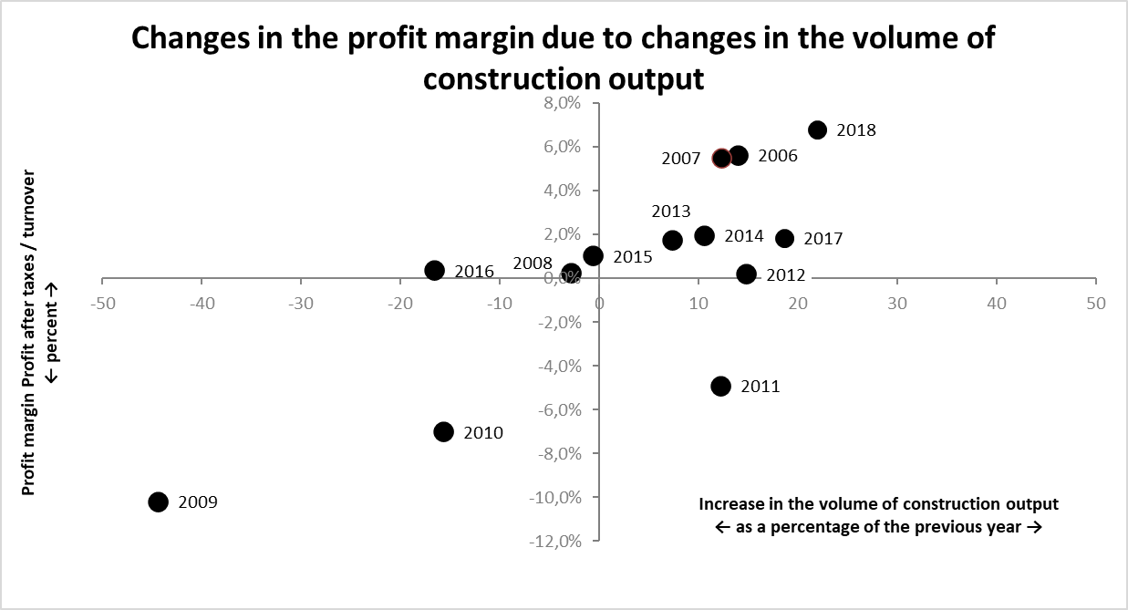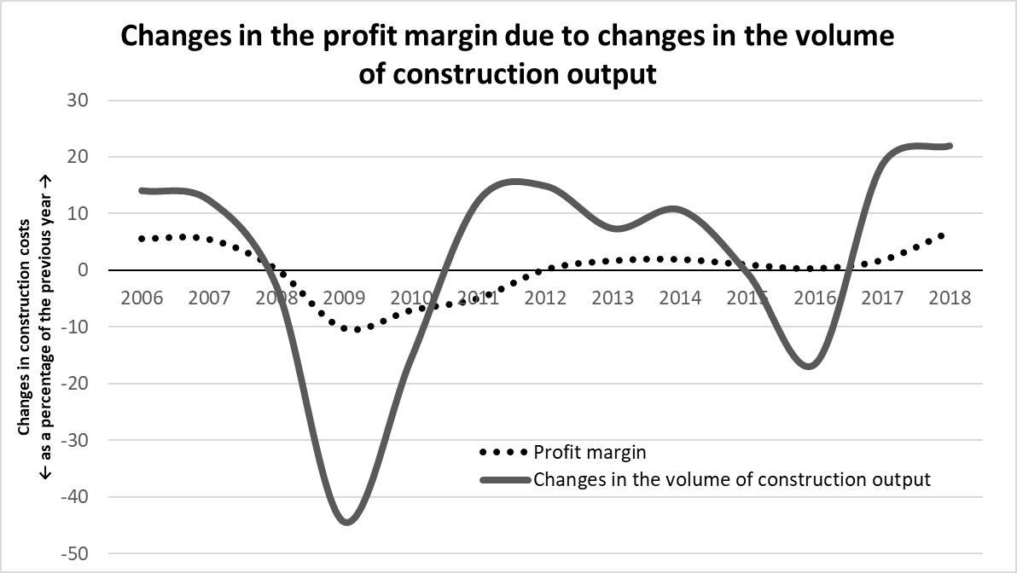
Fig. 19. The average profit rate of construction output and construction companies from 2006 to 2018.

Similar to the situation with construction costs, the profit margin in the period under review has an average relationship with the volume of construction output. In most cases, in the case of positive growth of construction output, companies worked on average with a positive profit margin, while during the decline in construction output, the profit margin also decreased and was often negative (2009-2011). Compared to the response of changes in costs to changes in construction output, the profit margin shows more stable, less jerky trends. In 2006 and 2007, the industry average was slightly above 5%. During the economic downturn, the national average fell sharply in 2009 to -10.7%, so the industry was operating at a loss on average. In 2010 and 2011, losses continued - -7.0% and -4.9%, respectively. Starting from 2012, the average profit is fluctuating between 0% and 2%. The last known period 2018 stood out with the most significant average profit margin in the industry for more than a decade.
Experts were offered various scenarios for changes in the volume of construction output. According to them, the experts provided their assessment of the changes in construction costs and the profit margin acceptable to contractors in each scenario (Fig. 19).
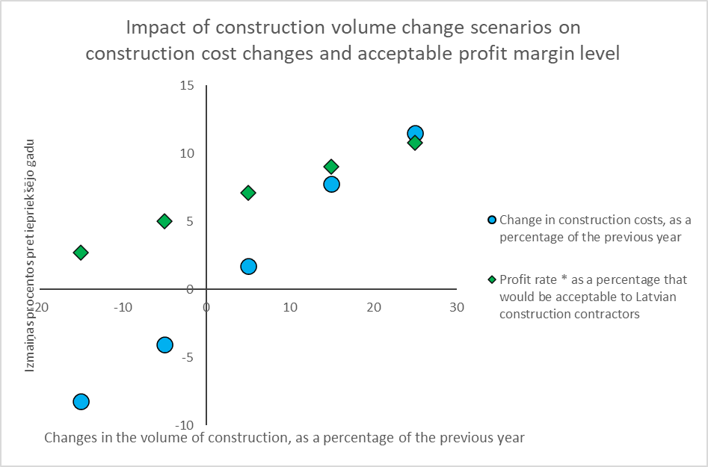
Fig. 20. Average expert assessments of the impact of construction volume change scenarios on construction changes and acceptable profit margins.
Assessing construction costs in a negative scenario, when construction output would decrease by -20% to -10%, the average assessment of experts is a change in construction costs of -8.23%. In turn, under the most optimistic construction development scenario, which envisages + 20% to + 30% growth per year, changes in construction costs are estimated at an average of 11.47%.
Table 29.
Average expert assessment of changes in construction costs and acceptable profit margin according to construction volume development scenarios.
Scenarios of changes in the volume of construction, as a percentage of the previous year | Average expert assessment of changes in construction costs, as a percentage of the previous year | The average expert assessment of the profit margin as a percentage, which would be acceptable to Latvian construction contractors
-20% to -10% | -8,23 | 2,67
-10% to 0% | -4,08 | 5,02
0% to +10% | 1,70 | 7,10
+10% to +20% | 7,73 | 9,04
+20% to +30% | 11,47 | 10,77

When assessing the acceptable profit margin, the experts gave an average positive assessment for all scenarios (Table 29). In the most pessimistic development scenario of the construction industry, the acceptable profit margin was estimated at 2.67%, while in the most optimistic case it was estimated at 10.77%. It should be noted that this estimate is directly acceptable, as in fact, during the periods when the construction sector experienced a decrease in volumes, the profit margin also used to be negative on average in the sector.
Looking at the view of the acceptable profit margin by sub-sectors, the average ratings of the companies representing the sub-sectors were obtained..

Table 30.
Comparison of the average expert assessment of the impact of construction volume change scenarios on the acceptable profit margin in sub-sectors.
Scenarios of changes in the volume of construction, as a percentage of the previous year | -20% to -10% | -10% to 0% | 0% to +10% | +10% to +20% | +20% to +30%
Construction of residential buildings | 2,83 | 5,15 | 6,69 | 9,23 | 11,50
Construction of non - residential buildings | 3,46 | 5,46 | 8,11 | 10,25 | 12,50
Construction of transport facilities | 4,38 | 5,29 | 6,00 | 7,19 | 8,29
Construction of city infrastructure objects | 2,60 | 4,60 | 7,83 | 9,60 | 9,80
Other civil engineering | 7,00 | 7,67 | 10,67 | 11,40 | 16,75

Based on the obtained results (Table 30), it can be concluded that the sub-sector that would be ready to work with a lower profit margin in more difficult conditions is the construction of residential buildings and construction of urban infrastructure objects. In these sub-sectors, at a negative industry growth rate (-20% to -10%), a profit margin of 2.83% and 2.60%, respectively, would be assumed. The most demanding profit margin, according to experts, is for the rest of the civil engineering industry, which would be ready for a correspondingly 7.00% profit margin.
The situation is slightly different in scenarios that envisage positive growth in construction. If the rest of the civil engineering management remained at the desired profit margin with high market growth, then the lowest position changes. With the growth of construction volumes above 10%, construction of transport objects is the sub-sector that is ready to work with the lowest profit margin. In the scenario 10-20% growth on average 7.19% profit margin and in the scenario 20-30% growth on average 8.29% profit margin.

Past scenarios with a cost / output ratio looking at critical periods of development
Within the framework of the study, the period up to 2006 was considered when performing a retrospective on changes in the volume of construction output and changes in construction costs. A significant event in this retrospective is the bubble in the construction sector and the overheating of the market in 2007-2008, which was followed by the economic downturn and crisis not only in the construction sector, but in the entire Latvian economy. It has been more than a decade since these events. Based on the observation that the length of economic cycles is usually observed on a 10-15 year scale, it can be considered that 2020 is a period close to the repetition of the cycle. Unlike the previous recession, this time the economy was negatively affected by the global pandemic and the consequences of measures taken to combat it. However, these events do not mean that the market imbalances that took place in 2007-2008 cannot be repeated. Therefore, it is important to observe whether similar trends exist.
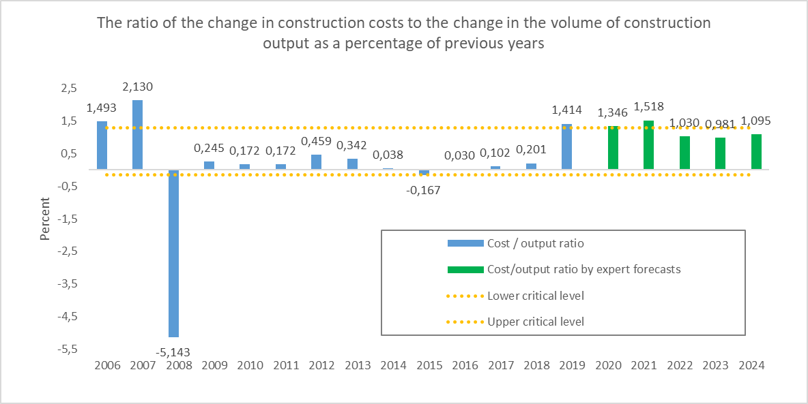
Fig. 21. The ratio of construction cost changes to production volume in 2006-2019 and their forecast for 2020-2024 and the risk of exceeding the critical limit.
As one way to identify risks, the authors use critical limits for the cost / output ratio on an annual basis. One of the indicators of the imbalance in construction is the relationship between construction output and costs. In case the total demand for construction products in the market increases, an increased demand for labor, construction materials and other resources is expected. In case the market is not able to provide entrepreneurs with the necessary resources, a situation arises with increasing demand and constant supply, which causes an increase in supply prices. It can be assumed that in a situation where costs increase more slowly than output, the situation is considered normal. On the other hand, if the increase in costs begins to approach or even exceeds the increase in the volume of production, then this may be an indicator of too rapid an increase in demand. In this case, we can talk about the risk of overheating, which could be followed by a market correction, which would mean a sharp drop in demand - a downturn.
In the period 2006-2019, the relationship between changes in construction costs and changes in construction output is determined. For the obtained time series, the mean value and standard deviation are calculated in this period, a critical limit is created, which is the amplitude of one standard deviation around the mean value. In the period under review, the cost / production ratio exceeds this critical limit in only two cases - in 2007 and 2008. Therefore, it can be considered that such an approach in retrospect makes it possible to identify the compliance of the actual overheating years with the one proposed by the critical limit.
Based on the obtained limits, simulation can be performed in combination with expert predictions.
Tabula 31.
Comparison of the obtained forecast ratios with the critical limit for overheating.
2020. | 2021. | 2022. | 2023. | 2024.
Cost / output ratio based on average expert forecasts
1,346 | 1,518 | 1,030 | 0,981 | 1,095
Exceeds critical limit | Exceeds critical limit | Below the critical limit, a downward trend | Below the critical limit, a downward trend | Below the critical limit, an upward trend
Cost / output ratio based on weighted combined (expert-statistical) forecasts
0,876 | 1,052 | 1,060 | 1,091 | 1,200
Below critical limits | Below the critical limit, an upward trend | Below the critical limit, a constant trend | Below the critical limit, an upward trend | Close to the critical limit, an upward trend

After the simulation, it can be concluded that based on the average expert forecasts and weighted combined (expert-statistical) forecasts, the degree of overheating risk varies depending on the type of forecast. If the average expert forecasts are used as the basic forecast, the year 2020 is closest to the critical limit. This year, the ratio is projected at 1.341, which is closest to the 2007 ratio of 2.130 and very close to the critical level of 1.761. The rest of the time periods have a slightly lower risk, but in all scenarios it is in the range of 0.444-0.510. In comparison, the risk weight of the weighted combined forecast is lower. These scenarios simulated higher growth rates in construction output but lower costs. Therefore, there is a low risk of overheating.
It is important to note that the limitation of such a simulation is the reliance on the reliability of expert forecasts. Of course, there are risks that an overly optimistic (low) cost estimate has been made in the future, which will not correspond to the real situation. To see alternative points of view, simulations provided by experts that are not linked to 2020-2024 will be considered..

Expert estimates of cost growth under various construction output growth scenarios
There is a possibility that the forecasts provided by the experts were too low due to various factors unknown to the researchers. Therefore, hypothetical scenarios provided by experts, which are not linked to the forecast period, were used. Under different scenarios of construction output volumes, the experts assessed the corresponding amount of cost changes.
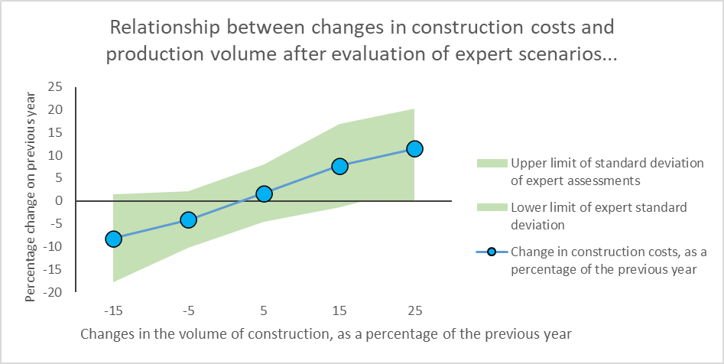
Fig. 22. Relationship between changes in construction costs and production volume after evaluation of expert scenarios.
In the previous crisis years, the restructuring of the construction sector was accompanied by an increase in construction costs above 20%, so it can be used as an indicator of critical costs, which may be followed by a market correction. According to the scenarios developed by the experts, the only option at which the area of ​​standard deviation of the expert assessments exceeds this limit is with the changes in the volume of construction faster than 20% compared to the previous year. Therefore, after such an approach, the risk of overheating in 2020-2024 is low.
In order to create a simulation of the possibility of overheating in the construction industry, only a multi-step analysis was performed. As a theoretical framework, the assumption remained that market overheating is caused by a faster rate of cost growth than output growth. Based on this assumption, the data of 2007-2008 were identified, which corresponded to the crisis situation, according to which the ratio of critical changes in construction costs and changes in the volume of construction output was determined by analogy. Extrapolation was performed to determine the values ​​for all possible combinations in the matrix with an increase in construction costs from 1 to 20 percent and an increase in construction output from 1 to 20 percent. The scenarios provided by the experts were used as baseline data. The first scenario used was expert-estimated forecasts for changes in construction output and costs between 2020 and 2024. The second used scenario was the amount of possible changes in construction costs estimated by experts at the proposed variants of changes in construction output. In the overheating likelihood simulation, both of these scenarios were combined to obtain an average estimate.
In the simulation for each construction output volume change option and for each construction cost change option combination, the ratio of these indicators is calculated according to a multifactor regression model, which is formed from the simulation data specified in the previous paragraph. The critical limit is 1.294, which was obtained from past scenarios.
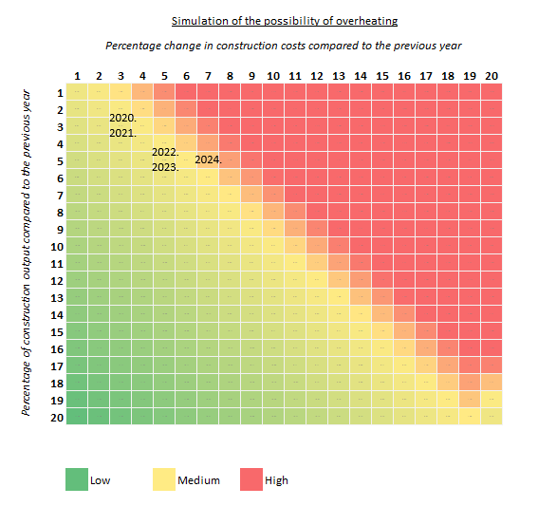
Fig. 23. Simulation of overheating of the construction industry at different variants of changes in the volume and cost of construction output by extrapolating expert estimates and forecasts and the situation of the previous recession. The years are given according to the combined forecast.
By supplementing the simulation of the possibility of overheating with combined (expert-statistical) forecasts, it can be observed that the increased risk of entering the economic overheating zone in such simulation is in 2024. In the remaining years forecast, the situation is close to the critical area, but is not yet considered to be significantly overheating. It should be noted that an important factor that cannot be quantified is the share of the shadow economy in the construction sector. However, the possibility that the shadow economy is a sufficiently significant problem essentially means shifting the simulation to the right along the horizontal axis at any change in construction costs, as there are costs not included in the data.

Proportion of total labor costs in construction in the volume of construction output and its dynamics
The overheating of the construction industry can also be viewed from the dynamics of labor costs in comparison with the dynamics of the volume of construction output in absolute units..
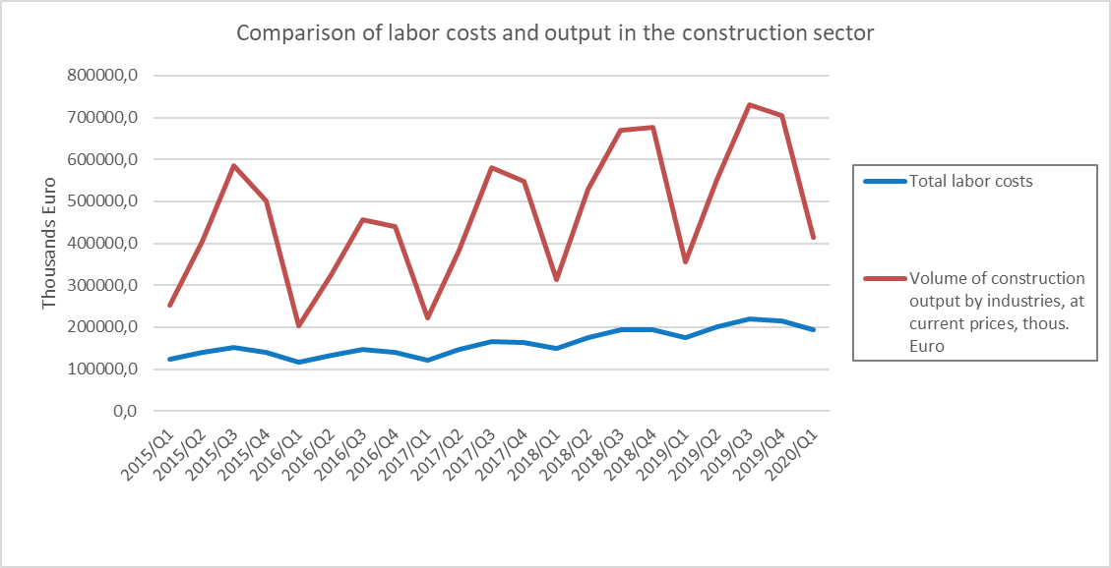
Fig. 24. Dynamics of construction output and labor costs in construction in 2015-2020 at current prices.

Looking at the period from 2015 to 2020, the researchers aim to identify whether there are unbalanced trends in the relationship between these two indicators. From the point of view of productivity, a desirable trend in the economy would be a smaller share of labor costs in the total output. Such a relationship would indicate higher labor productivity, or one unit of money spent on labor provides a larger amount of output. The opposite situation would be a sign of overheating. Increased labor costs in a situation where construction output is not growing so fast is an indicator that labor is not working productively and is overpaid, ie wages do not correspond to the real benefit to entrepreneurs.
In the available data cut-off, the situation can be described as relatively stable.
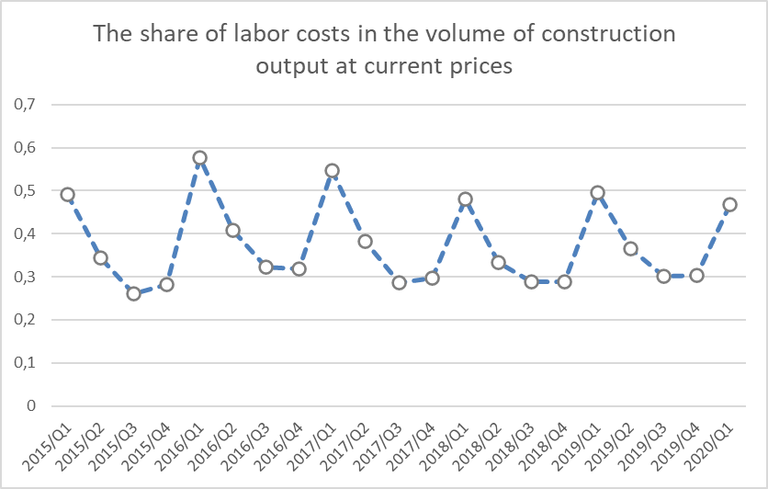
Att. 25. Būvniecības produkcijas un darbaspēka izmaksu būvniecībā attiecība 2015.-2020.gadā.
Although the situation for the season is considered, the overall trend is downward and can be interpreted as a declining share of labor costs in total construction output. This can be seen as a good signal that there is no unreasonable dynamics of labor costs that do not correspond to the real turnover of companies.
There is a risk that the previous conclusion could be misleading if the shadow economy factor is taken into account. Some construction companies may use unregistered labor, so the labor costs considered do not correspond to the real situation and are even higher for companies. Such public information on undeclared work is not available, which limits the use of this approach as an indicator of overheating.
One of the limiting factors for the growth of the construction industry is the availability of labor. Higher volumes of construction output, provided that there is no significant increase in automation and productivity, require a certain number of jobs. Of course, in Latvia, the increase in the degree of automation and productivity means that additional construction products are possible with an ever-decreasing number of employees, which was taken into account using nonlinear relationships..
Volume of construction at current prices, billion euro | 2,0 | 2,1 | 2,2 | 2,3 | 2,4 | 2,5 | 2,6 | 2,7 | 2,8 | 2,9 | 3,0
Projected required jobs in construction, thous. | 60 | 62 | 63 | 65 | 67 | 68 | 70 | 72 | 74 | 76 | 78
Fig. 26. Forecasts of construction output and the number of jobs under different scenarios based on 2009-2019. data and non-linear evolution.
Summarizing the information presented in this chapter, the researchers believe that in the period from 2020 to 2024 there is no unambiguous information that would allow to state that there is a high risk of overheating of the construction industry. However, as the year closest to the risk area, the authors consider 2021 to be a year of rapid jump in construction output after the impact of the pandemic and the introduction of stimulus measures at the labor market, which is not yet so flexible and able to provide new staff..

Conclusions

- As a result of the combined statistical and expert assessment forecast, it was concluded that the total volume of construction output in 2020 could increase by 3.07%, in 2021 by 3.25%.
According to experts, the total volume of construction output will increase by 3.4% per year on average, increasing by 0.41% in 2020 and increasing by 1.04% in 2021.
Based on the current downturn in the Latvian economy, the authors consider the expert assessment to be more reliable.
- As a result of the combined statistical and expert assessment forecast, it was concluded that the total construction costs will increase on average by 4.6% per year in the period from 2020 to 2024, respectively, increasing by 2.69% in 2020, increasing in 2021 by 3.41%.
According to experts, the total construction costs will increase on average by 3.6% per year in the period from 2020 to 2024.
- Wages and salaries are the position of construction costs with the highest projected increase in prices during the study period. Over the forecast period, labor costs are projected to increase by an average of 9.2% per year, followed by architectural and engineering services; technical inspection and analysis costs with an average annual increase of 4.9%.
- The average annual increase in the costs of construction materials is forecasted by 3.1% and the average annual increase in the costs of maintenance and operation of machinery and equipment by 2.4%.
- In the opinion of general experts, the most significant factors that will affect labor costs in the construction sector for 2020 - 2024 in Latvia are:
• Labor tax level in Latvia;
• Volume of construction in Latvia;
• The amount of construction plans implemented with public funds;
• Extent of measures to combat the shadow economy in Latvia.
- In the assessment of sub-sector experts, the most significant factors that will affect labor costs in the construction sector in 2020 - 2024 in Latvia are:
• Labor tax level in Latvia;
• Volume of construction in Latvia;
• The level of labor wages in the EU countries in the construction sector;
• EU labor demand in the construction sector.
- In the opinion of general experts, the most important factors that will affect the costs of construction materials in the construction sector for 2020-2024 in Latvia are:
• Volume of construction in Latvia;
• The amount of construction plans implemented with public funds;
• Changes in gross domestic product in Latvia;
• Real estate lending volumes in Latvia.
- In the assessment of sub-sector experts, the most significant factors that will affect the costs of construction materials in the construction sector in 2020-2024 in Latvia are:
• Volume of construction in Latvia;
• EU total construction market demand;
• Average fuel price in Latvia;
• Competitive concentration indicators in the building materials market in Latvia
- In the opinion of general experts, the most significant factors that will affect the costs of construction materials in the construction sector in 2020-2024 in Latvia are:
• Volume of construction in Latvia;
• The amount of construction plans implemented with public funds;
• Changes in gross domestic product in Latvia;
• Real estate lending volumes in Latvia.
- In the assessment of sub-sector experts, the most significant factors that will affect the costs of construction materials in the construction sector in 2020-2024 in Latvia are:
• Volume of construction in Latvia;
• EU total construction market demand;
• Average fuel price in Latvia;
• Competitive concentration indicators in the building materials market in Latvia.
- According to the experts of the residential and non-residential building construction sub-sector, the most important of the studied factors that affect both labor and construction material costs is the volume of construction in Latvia.
- According to the experts of the transport facilities construction sub-sector, the most important of the researched factors that affect both labor costs is the uneven attraction, planning and use of EU funds in the construction sector within the planning period. Coordinated use of available funding and uneven amount of available funding in a certain period of time were recognized as the most significant factor influencing the cost of construction materials.
- According to the experts of the sub-sector of construction of urban infrastructure objects, the most important of the studied factors that affect labor costs is the shortage of labor. In turn, the cost of construction materials is most significantly affected by the availability of steel pipes and fittings and their price level in the EU market.
- According to the experts of the rest of the civil engineering sub-sector, the most important factors influencing labor costs are both the lack of qualified labor and the competition of employers in attracting these qualified employees. The cost of construction materials is most significantly influenced by the volume of construction output in the country
- The combined forecasts by groups of objects identify an increase in construction costs in all types of resources until 2024, but in earlier periods a short-term decrease in costs is forecasted in several sub-sectors.
- In construction of residential and non-residential buildings in 2020, a decrease in construction costs is forecasted by 0.53% and 1.23%. In the period until 2024, on the other hand, an increase in costs is forecasted, reaching 5.68% per year for residential buildings and 4.01% per year for non-residential buildings.
- In the construction of transport objects, relatively high changes in construction costs are forecasted in the total period under review.
- In the construction of roads and highways, sub-sector experts forecast a significant reduction in costs in 2020 with a change of -8.5%, which, however, could turn into an increase in costs in the coming years, reaching an annual increase of 6.88% in 2024.
- In railway construction, taking into account also the projected increase in construction volumes, a moderate increase in costs by 1.00% is forecasted in 2020, followed by a faster increase in 6.921 by 6.00%. In the coming years, experts forecast a lower growth each year, reaching +2.50% in 2024.
- The construction of bridges and tunnels has the highest increase in the projected construction costs in 2020 from the group of transport objects with + 1.57%. In the following years, a relatively constant annual growth of 6.57% until 2024 is forecast.
- The highest cost increase in the construction of urban infrastructure objects in 2020 is forecasted from those considered in the subsector, which is 2.67% per year. In 2021, it will reach 3.33% and may exceed 4% in the following years.
- In other civil engineering, experts forecast a moderate increase in costs in 2020 with 0.71%, followed by a 4.97% increase in costs in 2021 and in the following years it will range from 4.10% per year to 5.11% per year.
- Looking at the more significant cost components of each sub-sector, it is concluded that in most cases in the period 2020-2024. the largest cost increases will be in the field of architecture and engineering services.
- In the residential buildings sub-sector, in 2020 the costs of all items are projected to decrease, especially for the maintenance of machinery and equipment by -1.22%. In 2021, prices are expected to rise in all positions, with the highest growth for workers' wages of 3.44% and architecture and engineering services with an increase of 3.44%.
- The trends in the non-residential buildings sub-sector are similar to a decrease in costs in 2020 in the same way as in the residential buildings sub-sector, and in 2021 the largest increase is expected in the field of architecture and engineering services 3.78%
- An increase in costs in the construction of transport facilities is expected in all periods. In 2020, the largest increase in costs is expected for construction materials and architectural and engineering services at 1.55%. In 2021, the most significant increase in costs is forecasted for construction materials costs of 4.68%.
- An increase in costs is expected in the construction of urban infrastructure objects in all periods. In 2020, the largest increase in costs is expected for architectural and engineering services by 2.00%. In 2021, the most significant increase in costs is forecast for workers' wages by 3.71%.
- In the other civil engineering sub-sector, in 2020 the reduction of costs is forecasted only for workers' wages by 2.00%. The largest increase is forecast for architectural and engineering services by 7.43%. In 2021, the most significant increase in costs remains for architectural and engineering services with an increase in costs of 8.43%.
- Under different scenarios of changes in the volume of construction, experts predict different changes in construction costs.
- Assessing construction costs, in a negative scenario, when construction output would decrease by -20% to -10%, the average assessment of experts is the change in total construction costs by -8.23%.
On the other hand, under the most optimistic construction development scenario, which envisages + 20% to + 30% growth per year, the changes in total construction costs are estimated on average as 11.47%.
- Based on the obtained results, it is concluded that a sub-sector that would be ready to work with a lower profit margin in a recession is the construction of urban infrastructure. In this sub-sector, at a negative industry growth rate (0% to -20%), a profit margin of 2.6% -4.60% would be acceptable. In turn, in the upturn of the market, the lowest profit margin is ready to be accepted by the sub-sector of construction of transport facilities with the level from 6.00% to 8.29%.
- Assessing the impact of the implemented and planned measures to combat the shadow economy on labor costs in the construction sector, it was concluded that most of the measures were assessed as non-impactful or low-impact. No measure was assessed as cost reducing. The most significant cost-increasing measure is considered to be the introduction of an electronic time and attendance system.
In general, experts see a 2-3 times greater impact of measures to combat the shadow economy on labor costs than on the cost of building materials. The impact on the cost of construction materials is assessed as insignificant
- In general, experts do not see a significant impact of the COVID-19 pandemic on construction costs. It is estimated that the impact will be higher on the cost of construction materials than on the cost of labor.
- In summarizing the findings, the researchers believe that there is no clear information between 2020 and 2024 that would suggest that there is a high risk of overheating in the construction industry. However, as the year closest to the risk area, the authors consider 2021 to be a year of rapid jump in construction output after the impact of the pandemic and the introduction of stimulus measures at the labor market, which is not yet so flexible and able to provide new staff.

Appendixes

Annex 1 - Organizations involved in the general expert survey
List of organizations:
- Association “Latvijas ceļu būvētājs”
- Association “Latvijas Būvuzņēmēju partnerība”
- Latvian Association of Building Designers (LBPA)
- Association “Latvijas elektroenerģētiķu un energobūvnieku asociācija”
- Latvijas Siltuma, Gāzes and Ūdens tehnoloģijas engineers' union
- Ministry of Finance
- Foreign Investors' Council in Latvia
- SEB bank
- RISEBA higher school
- LLC “ACB”
- PLC “Latvijas valsts ceļi”
- LLC "IRPU"
- SP “GAMA”
- LLC “Ceļu būvniecības sabiedrība “IGATE”
- LLC “OROCON”
- LLC L.B.T.S.

Annex 2 - Companies involved in the survey of sub-sector experts

Construction of residential and non - residential buildings:
- Riga Technical University
- Latvian Union of Architects
- PLC ''Valsts nekustamie īpašumi''
- LLC “Rigensi”
- LLC "Baltic Construction Alliance"
- LLC “Jēkabpils PMK”
- LLC “Baltic Construktion Consultancy”
- LLC “Neverenc”
- LLC “REM PRO”

Construction of transport facilities:
- VAS “Latvijas dzelzceļš”
- VAS "Latvijas autoceļu uzturētājs"
- JCC “LATVIJAS TILTI”
- Latvian Transport Development and Education AssociationLLC "8 CBR"
- LLC CBF Binders
- LLC “VIGILANTIAE”
- LLC “Strabag”
- LLC “JURIS ROZĪTE”
- LLC BŪVINŽENIERIS
- LLC “Saldus ceļinieks” group

Urban infrastructure construction sub - sector
- Latvian Union of Civil Engineers
- LLC Citrus Solutions
- LLC “BAU ID”
- LLC FILTER Latvia
- LLC "Norma-S"
- LLC “Hektors”
- LLC “Amatnieks”

Other civil engineering sub - sector
- Latvian Union of Civil Engineers
- LLC “Newcom Construction”
- LLC “BIANT”
- LLC “KORO BŪVE”
- LLC “NOILLIM”
- LLC “Grobiņas SPMK”
- LLC “RIO”
- LLC “A-Land”

Būvniecības izmaksu indeksi, Centrālā statistikas pārvalde, 29.05.2018., pieejams http://www.csb.gov.lv/statistikas-temas/metodologija/buvniecibas-izmaksu-indeksi-34819.html (skatīts 01.06.2018.)
Fox, John, Applied regression analysis and generalized linear models / John Fox. Third Edition Los Angeles : SAGE, [2016], p.425-476

